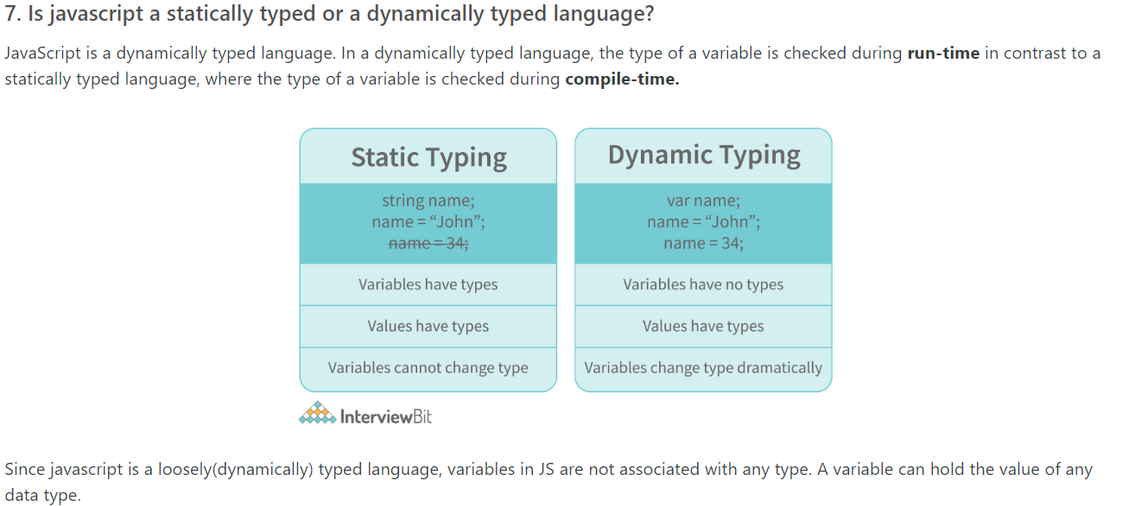

**CLOSURE**

Js uses lexical scoping – any variable defined outside of a function is automatically available inside the function. So any function where we’re using variable from outside its scope is actually a closure

*Способността на фукнцията да взима променлива от външен скоуп и да я пази за бъдеща рефенция, дори след като се е изпълнила, се нарича Closure. Closure им достъп до променсливи в три скоупа: променливи в собствения си скоуп, пром. в скоупа на външната функция, пром. в глобалния скоуп. Също така Closure функцията им достъп до собствените си параметри, както и парам. на външната функция*

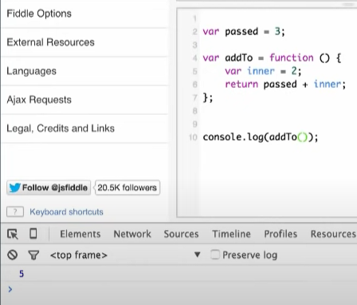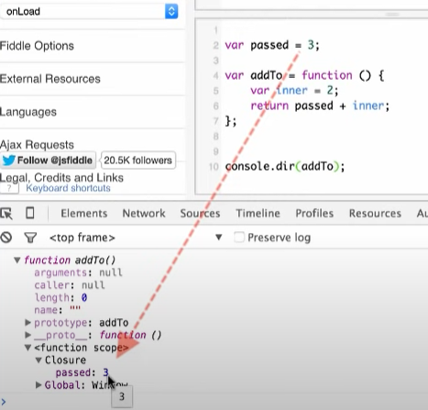

Фукнцията addTo ще види, че passed не е дефинира в нея и ще започне да я търси във външния скоуп. Ако и там не я намери, ще продължи към следващия външен скоуп и т.н. Ако никъде не я намери, ще изпише undefined

*function* closure() {

*const* person = { *name:* *'*Sasho*'*, *age:* 35 };

*return* *function* () {

    console.log(person.*name* + *'* sucks*'*); *// Has access to obj1 even when the randomFunc function is executed*

  };

}

*// Първо се изпълнява closure() и тя връща функция, която запазваме в initialClosure*

*const* initialiseClosure = closure();

*// След това върната функция се изпълнява, когато извикаме initialClosure()*

initialiseClosure();

*// closure() вместо да унищожи стойността на person след като се е изпълнила, запазва нейната стойност в паметта а бъдеща референция*

*// Поради тази причина, фукцията, върната в return, може да използва стойнността на промелнивата, декларирана във външния скоуп, дори след като*

*// функцията вече се е изпълнила. Способността на фукнцията да пази променлива за бъдеща рефенция, дори след като се е изпълнила, се нарича Closure*

Lexical scoping means that inside the inner scope you can access variables of outer scopes.

A rule of thumb to identify a closure: if inside a function you see an alien variable (not defined inside that function), most likely that function is a closure because the alien variable is captured.

**CALLBACK**

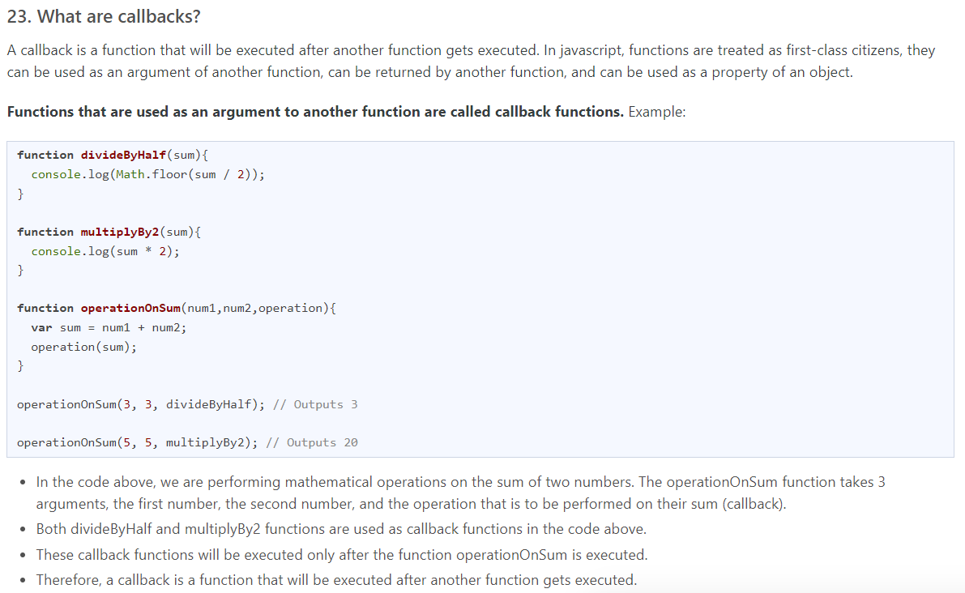

**ARROW FUNCTIONS**

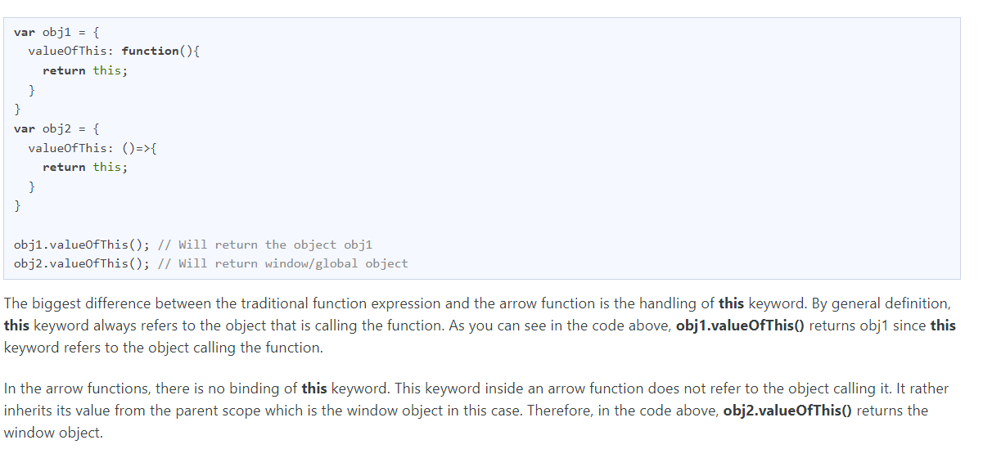

**Value vs Reference Types**

В JS имаме primitives and objects (since functions and arrays both are objects). Примитивните се копират по стойност, обектите по референция

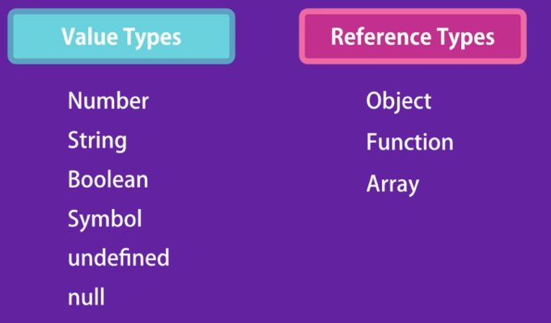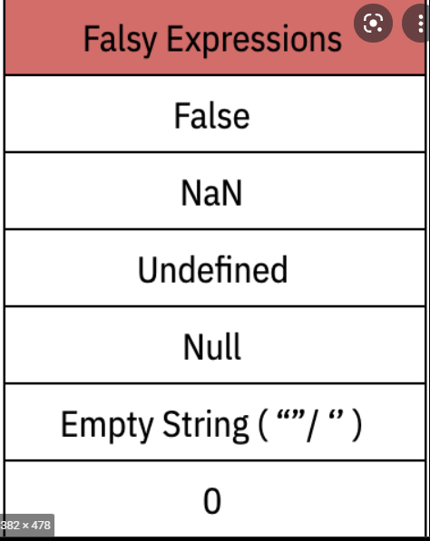

Value/primitive types са независими – стойността им се запазва в самата променлива. Когато копираме променливата (х), неговата стойност (10) се копира в новата променлива (у), така че двете променливи са напълно независими една от друга:

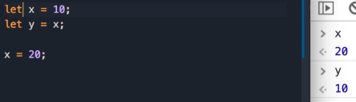

Когато обаче използваме обект, този обект не се пази в съответната променлива (х), а някъде другаде в паметта. И адресът на тази локация в паметта се запазва в тази променлива

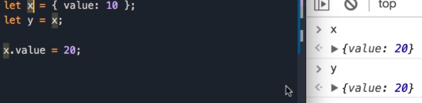 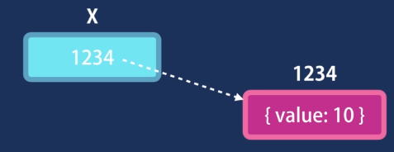

Така че, когато копираме let y = x, копираме адреса или референцията, а не самата стойност. И двете х и у сочат към един и същ адрес в паметта: И когато променяме този обект, без значение дали през х или през у, промените веднага се отразяват и в другата променлива

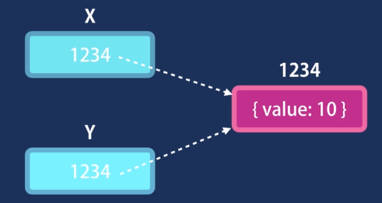

**String**

Първата константа е string primitive, втората е обект. Когато обаче използваме the dot notation with string primitive, JS engine internally wraps this with a string object.

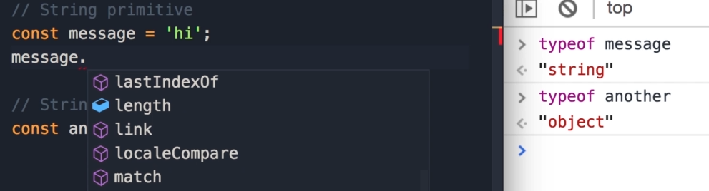

Ако използваме replace, това не модифицира оригиналния стринг, а връща нов стринг:

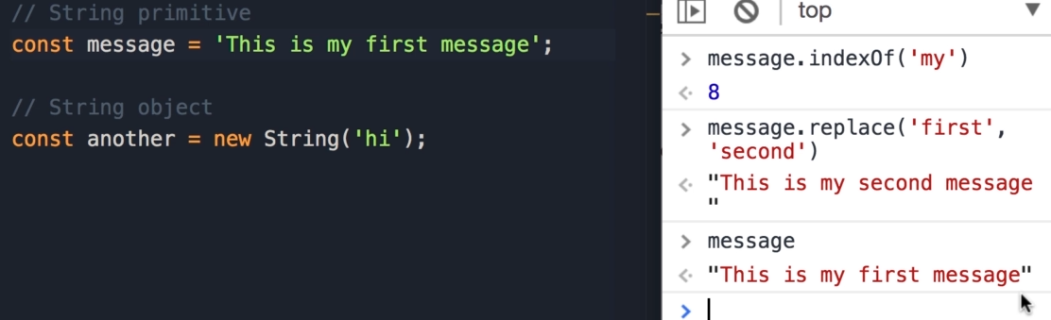

**Factory func vs Constructor functions**

Когато използване оператора new, се случват три неща: първо се създава празен JS обект (const circle = {}). След това прави така, че this да сочи към този празен обект и му задаваме пропъртитата radius и draw. И накрая връща този нов обект от тази функция Circle(radius). Което прилича на return this – това не се слага експлицитно във функцията, то се случва автоматично. Това, което имаме е нов обект и съответно правим const circle да сочи към този обект

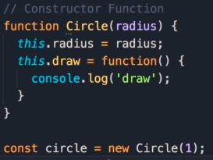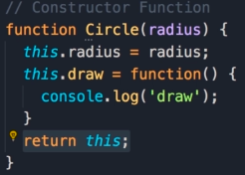

При factory function просто извикваме тази функция и тя ни връща нов обект: Другата разлика е, че двете използват различни конвенции за наименование – camel Notation I Pascal naming convention

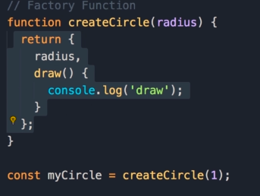

Всеки обект има контруктор пропърти:

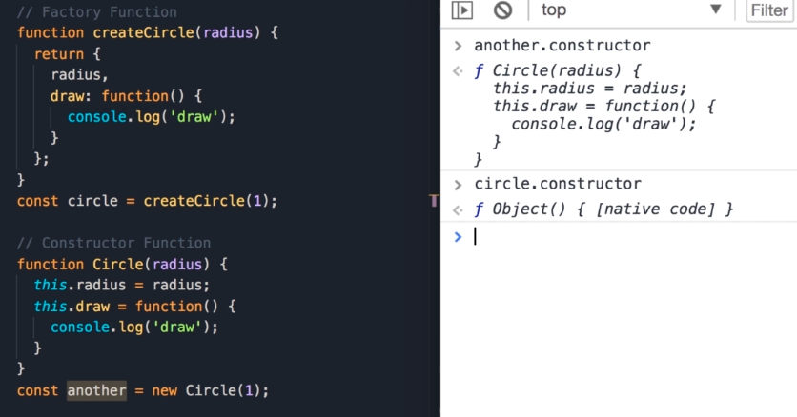

circle.constructor e built in contructor in JS. Когато създаваме обект чрез object literal syntax, JS вътрешно използва този contructor function. Така, когато създаваме обект по следния начин let x = {};, JS преобразува вътрешно това до следното: let x = new Object(); Други подобни built-in конструктори са new String(); new Boolean(); new Number();

Всеки обект има constructor property, което е референция към функцията, която е използвана за създаването на обекта. Функциите са обект, а те се създават от built-in конструктора new Function(); Съответно теоретично можем да ме създадем фукнцията по следния начин, който би бил еднакво валиден:

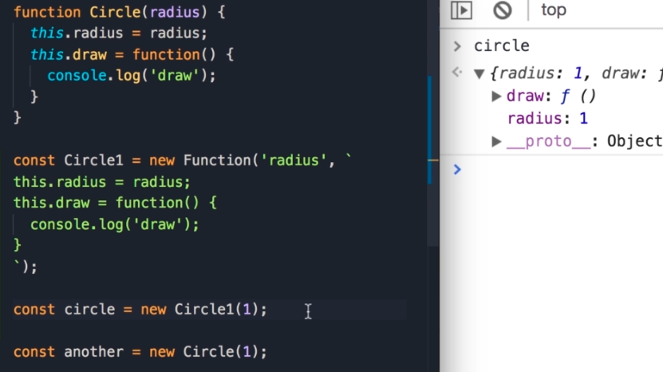

Circle.call({}) – по този начин this ще референтва към празния обект, който подаваме като аргумент, след което си подаваме аргументите. Съответно Circle.call({}, 1) е същото като new Circle(1). Когато използваме new operator, той вътршно създава празен обект и го подава като първи параметър към call method и този обект ще определи контекста на this, this ще референсва този обект. Ако обаче не ползваме new operator, this сочи към глобалния обект, който е window

**THIS**

This референсва обектът, който изпълнява текущата функция. Ако this е част от метод, той реферира обектът, в който методът се намира. Ако this е част от функция, тогава той реферира глобалния обект (window in browsers, но ако ‘strict mode’ is enabled, например в Реакт, тогава ще върне undefined)

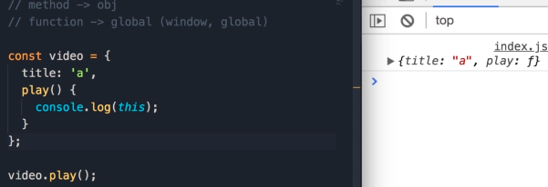

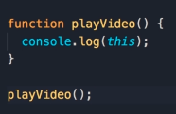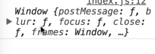

This in constructor functions: Когато използване оператора new, се случват три неща: първо се създава празен JS обект (const v = {}). След това прави така, че this да сочи към този празен обект и му задаваме пропъртитата title. И накрая връща този нов обект от тази функция Video(title). Което прилича на return this – това не се слага експлицитно във функцията, то се случва автоматично. Това, което имаме е нов обект и съответно правим const v да сочи към този обект

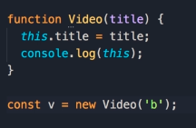 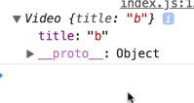

В тази функция обаче, this ще върне рефенция към window object. Понеже this се намира в callback function, тази функция се третира като обикновена фукнция, а не метод в person. Единственият метод, който имаме е talk(). И защото е обикновена фукнция, this реферира глобалния обект. Има няколко варианта да се коригира – единият е да си декларираме променлива self в метода и после да я подадем на callback функцията. Този варинт не е особено препоръчителен

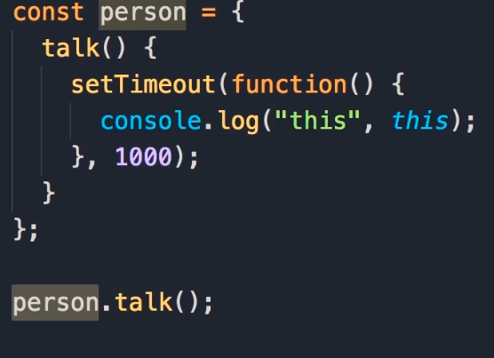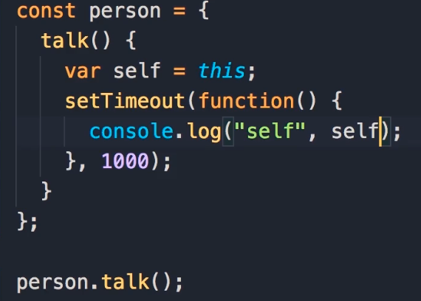

С методите call, appy & bind можем да променяме можем да променяме стойността на this за съответната фукнция.

*const* person = {

*name:* *'*Sasho*'*,

  talk() {

    setTimeout(*function*() {

      console.log(*'*this in setTimeout*'*, *this*.*name*)

    }.call(*this*), 1000)

  }

}

person.talk();

Но тук ако решим да подадем друг обект, с който да се извика, можем да направим сленото:

}.call({*name:* *'*Gosho*'*}), 1000)

И това ще изпише Gosho

Appy е същият метод, с разликата, че при него параметрите трябва да се подават като array

*function* playVideo(a, b,) {

  console.log(a, b)

  console.log(*this*)

}

playVideo.call({*name:* *'*Sasho*'*}, 1, 2)

playVideo.apply({*name:* *'*Sasho*'*}, *[*1, 2*]*)

playVideo.bind({*name:* *'*Sasho*'*})();



Bind не извиква playVideo фукцията. Той връща нова функция и задава this да сочи към подадения обект постоянно. Съответно без значение как извикваме тази функция, this винаги ще сочи към подадения обект.

Съответно чрез bind() е второто решение на проблема с this

}.bind(*this*), 1000)

Functions in JS are objects – they have properties and methods we can use. With the bind method we can set the value of ‘this’ permanently. So when we call bind on the walk function, we get a new function and in this new function this is based on the argument that we pass to the bind method:

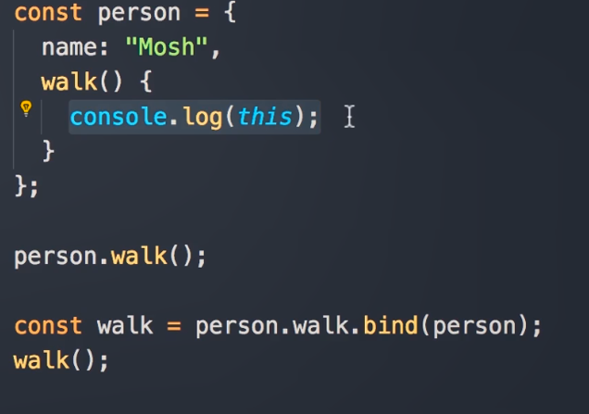

Но най-доброто решение е използването на arrow functions, защото те наследят стойността на this от съдържащата функция. Или иначе казано, this не се реинициализира към нов обект

*const* person = {

*name:* *'*Sasho*'*,

  talk() {

    setTimeout(() *=>* {

      console.log(*'*this in setTimeout*'*, *this*.*name*)

    }, 1000)

  }

}

person.talk();

BIND:

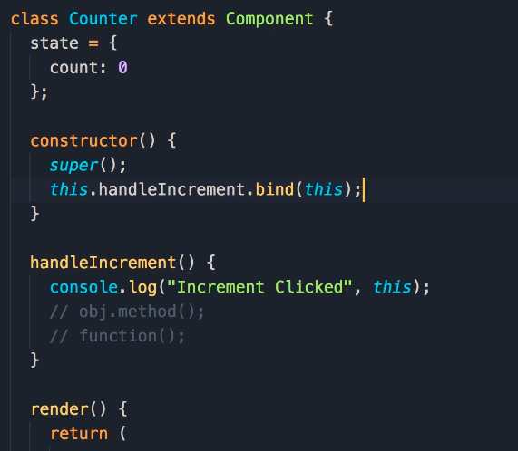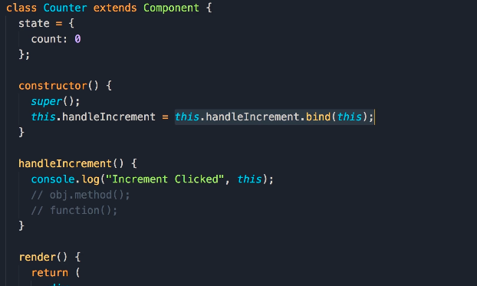

This is handleIcrement is undefined (points to the window object in strict mode). So in order for us to have access, we must bind it in the constructor, because in the constructor we have access to this. This bind method will return a new instace of the handleIncrement function and in that function this is always referencing the current object, so no matter how that function is call this will not change – it’s always referencing the current Counter object.

So we can get that function and reset handleIncrement with the proper reference to this. But the the best solution is to convert handleIncrement to an arrow function, beucase they don’t rebind this keyword, they inherit it

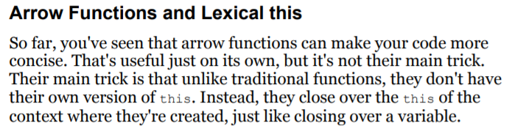

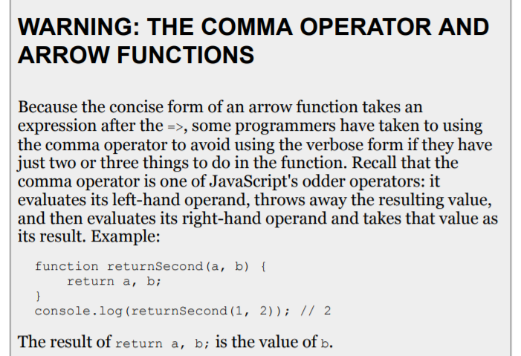

**PURE FUNCTIONS**

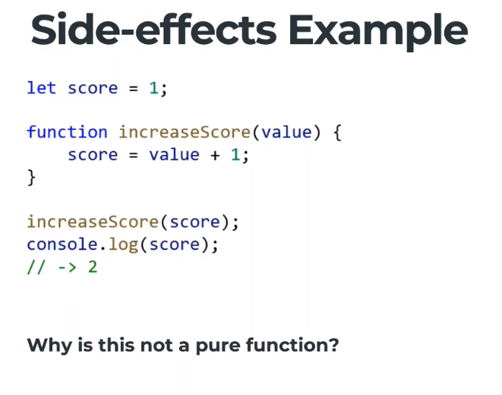 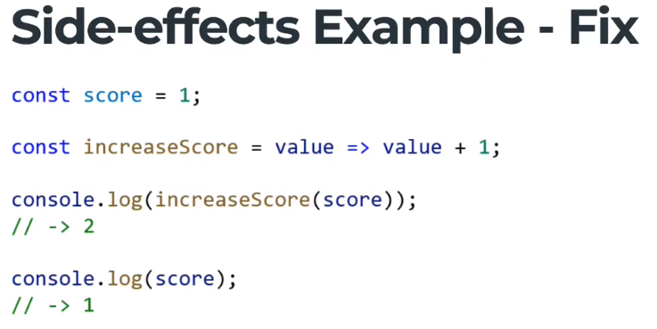

Така създаваме нов стейт на score, функцията не променя стейта, ами създава нов.

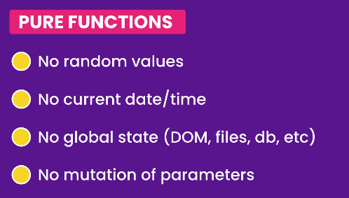

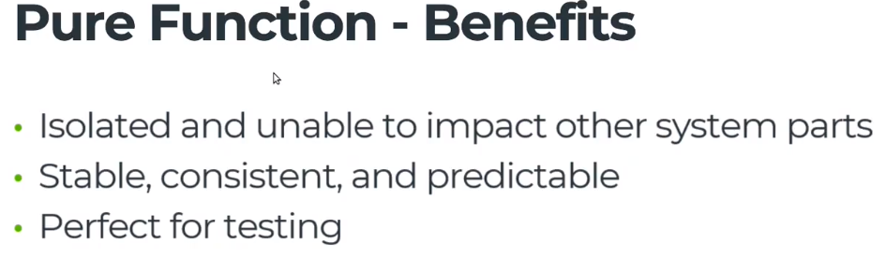

**Use Strict**

* **Makes debugging easier.** Code errors that would otherwise have been ignored or would have failed silently will now generate errors or throw exceptions, alerting you sooner to problems in your code and directing you more quickly to their source.
* **Prevents accidental globals.** Without strict mode, assigning a value to an undeclared variable automatically creates a global variable with that name. This is one of the most common errors in JavaScript. In strict mode, attempting to do so throws an error.
* **Eliminates**this**coercion**. Without strict mode, a reference to a this value of null or undefined is automatically coerced to the global. This can cause many headfakes and pull-out-your-hair kind of bugs. In strict mode, referencing a a this value of null or undefined throws an error.
* **Disallows duplicate parameter values.** Strict mode throws an error when it detects a duplicate named argument for a function (e.g., function foo(val1, val2, val1){})

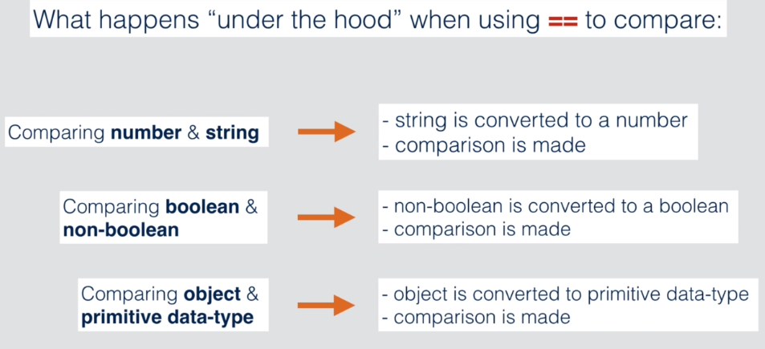

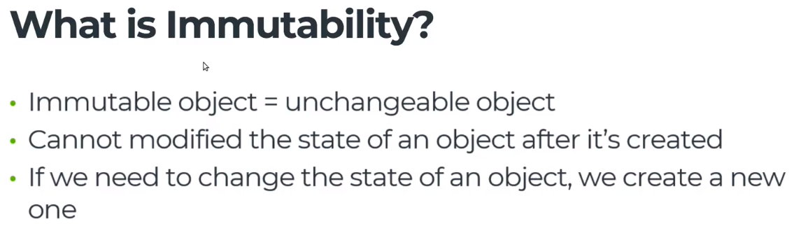

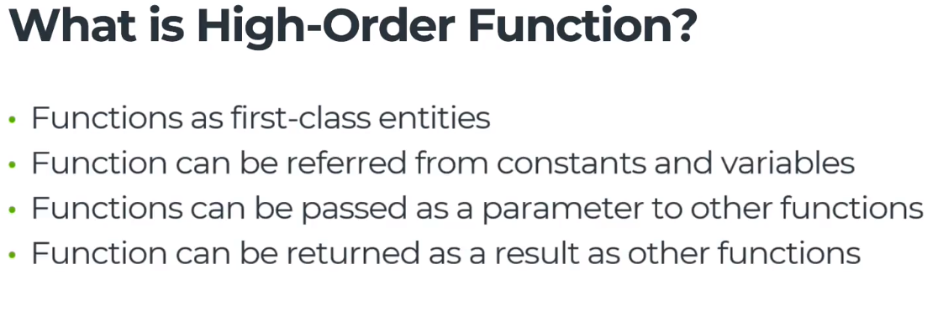

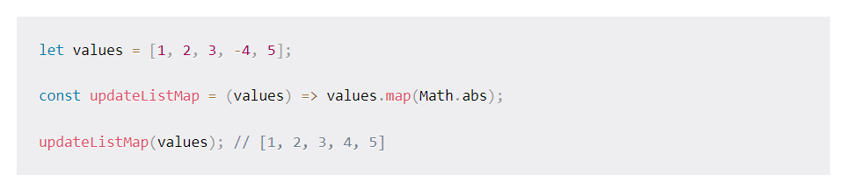

**SHALLOW COPY**

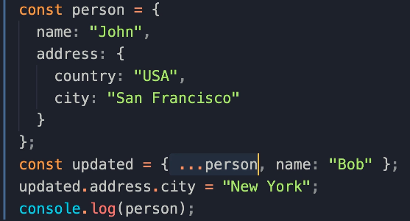

… operator does a shallow copy, meaning that if we update the address property in updated, it will also update it in person.

Both have the same address, it is the same address object in memory. To solve this problem we need to do a deep copy:

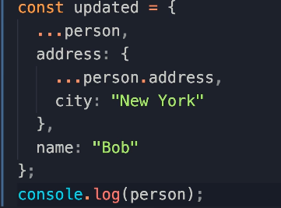

In order to make this easier, there are libraries that take care of deep copy of objects

**UPDATING ARRAYS**

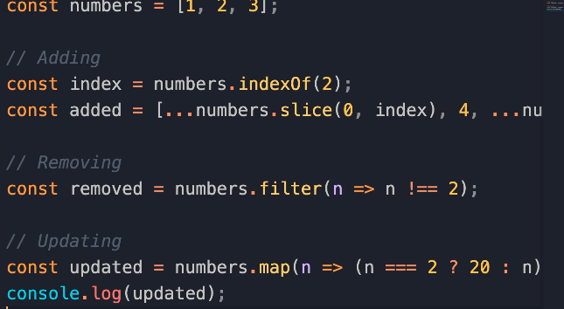

**FUNCTIONAL PROGRAMMING**

It is about decomposing a problem into a bunch of small and reusable functions that take some input and return a result. They don’t mutate or change data. Example React Components. Advantages are that these small functions (components) are more concise, easier to debug, easier to test and more scalable

**HTTP**

HTTP is an TCP/IP based communication protocol, which is used to deliver data (HTML files, image files, query results etc) on the World Wide Web. The default port is TCP 80, but other ports can be used. It provides a standardized way for computers to communicate with each other. HTTP specification specifies how clients request data will be constructed and sent to the server, and how servers respond to these requests.

HTTP is connectionless: The HTTP client ie. browser initiates an HTTP request and after a request is made, the client disconnects from the server and waits for a response. The server process the request and re-establish the connection with the client to send response back.

HTTP is stateless: As mentioned above, HTTP is a connectionless and this is a direct result that HTTP is a stateless protocol. The server and client are aware of each other only during a current request. Afterwards, both of them forget about each other. Due to this nature of the protocol, neither the client nor the browser can retain information between different request across the web pages.

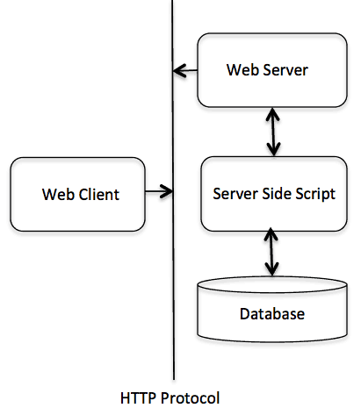

The HTTP protocol is a request/response protocol based on client/server based architecture where web browser, robots and search engines, etc. act like HTTP clients and Web server acts as server.

Client

The HTTP client sends a request to the server in the form of a request method, URI, and protocol version, followed by a MIME-like message containing request modifiers, client information, and possible body content over a TCP/IP connection.

Server

The HTTP server responds with a status line, including the message's protocol version and a success or error code, followed by a MIME-like message containing server information, entity metainformation, and possible entity-body content.

**The version of an HTTP** message is indicated by an HTTP-Version field in the first line.

**Uniform Resource Identifiers (URI)** is simply formatted, case-insensitive string containing name, location etc to identify a resource, for example a website, a web service etc. A general syntax of URI used for HTTP is as follows:

URI = "http:" "//" host [ ":" port ] [ abs_path [ "?" query ]]

Here if the **port** is empty or not given, port 80 is assumed for HTTP and an empty **abs_path** is equivalent to an **abs_path** of "/".

# **HTTP - Messages**

HTTP is based on client-server architecture model and a stateless request/response protocol that operates by exchanging messages across a reliable TCP/IP connection.

An HTTP "client" is a program (Web browser or any other client) that establishes a connection to a server for the purpose of sending one or more HTTP request messages. An HTTP "server" is a program ( generally a web server like Apache Web Server or Internet Information Services IIS etc. ) that accepts connections in order to serve HTTP requests by sending HTTP response messages.

HTTP makes use of the Uniform Resource Identifier (URI) to identify a given resource and to establish a connection. Once connection is established. These messages are consisted of **requests** from client to server and **responses** from server to client which will have following format: HTTP-message = <Request> | <Response> ; HTTP/1.1 messages

A Start-line

Zero or more header fields followed by CRLF

Optionally a message-body

**Start-line:**

GET /hello.htm HTTP/1.1 (This is Request-Line sent by the client)

HTTP/1.1 200 OK (This is Status-Line sent by the server)

**HTTP header fields** provide required information about the request or response, or about the object sent in the message body. There are following four types of HTTP message headers:

* **General-header:** These header fields have general applicability for both request and response messages.
* **Request-header:** These header fields are applicability only for request messages.
* **Response-header:** These header fields are applicability only for response messages.
* **Entity-header:** These header fields define metainformation about the entity-body or, if no body is present

Following are the examples of various header fields:

User-Agent: curl/7.16.3 libcurl/7.16.3 OpenSSL/0.9.7l zlib/1.2.3

Host: www.example.com

Accept-Language: en, mi

Date: Mon, 27 Jul 2009 12:28:53 GMT

Server: Apache

Last-Modified: Wed, 22 Jul 2009 19:15:56 GMT

Accept-Ranges: bytes

Content-Length: 51

Content-Type: text/plain

**The message body** part is optional for an HTTP message but if it is available then it is used to carry the entity-body associated with the request or response. If entity body is associated then usually **Content-Type** and **Content-Length** headers lines specify the nature of the body associated.

A message body is the one which carries actual HTTP request data (including form data and uploaded etc.) and HTTP response data from the server ( including files, images etc). Following is a simple content of a message body:

<html>

<body>

<h1>Hello, World!</h1>

</body>

</html>

# **HTTP - Requests**

An HTTP client sends an HTTP request to a server in the form of a request message which includes following format:

**A Request-line**

**Zero or more header (General|Request|Entity) fields followed by CRLF**

**Optionally a message-body**

## **Message Request-Line**

The Request-Line begins with a method token, followed by the Request-URI and the protocol version, and ending with CRLF. The elements are separated by space SP characters.

## **Request Method**

The request **Method** indicates the method to be performed on the resource identified by the given **Request-URI**.

|  |  |
| --- | --- |
| **S.N.** | **Method and Description** |
| 1 | **GET** The GET method is used to retrieve information from the given server using a given URI. Requests using GET should only retrieve data and should have no other effect on the data. |
| 2 | **HEAD** Same as GET, but only transfer the status line and header section. |
| 3 | **POST** A POST request is used to send data to the server, for example customer information, file upload etc using HTML forms. |
| 4 | **PUT** Replace all current representations of the target resource with the uploaded content. |
| 5 | **DELETE** Remove all current representations of the target resource given by URI. |

## **Request-URI**

The Request-URI is a Uniform Resource Identifier and identifies the resource upon which to apply the request.

## **Request Header Fields**

The request-header fields allow the client to pass additional information about the request, and about the client itself, to the server. These fields act as request modifiers and there are following important Request-header fields available which can be used based on requirement.

* Accept-Charset
* Accept-Encoding
* Accept-Language
* Authorization
* Host
* Connection
* User-Agent

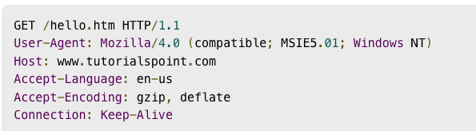

# **HTTP - Responses**

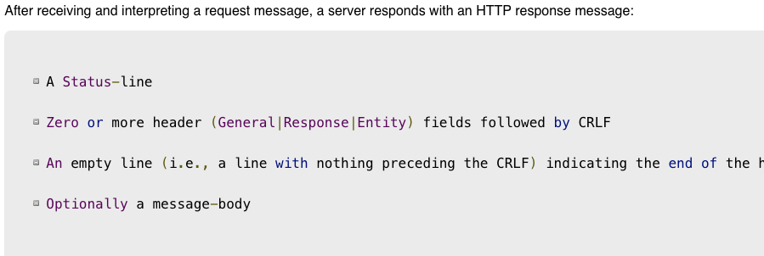

## **Message Status-Line**

The Status-Line consisting of the protocol version followed by a numeric status code and its associated textual phrase. The elements are separated by space SP characters.

## **Status Code**

The Status-Code element is a 3-digit integer where first digit of the Status-Code defines the class of response and the last two digits do not have any categorization role. There are 5 values for the first digit:

|  |  |
| --- | --- |
| **S.N.** | **Code and Description** |
| 1 | **1xx: Informational** This means request received and continuing process. |
| 2 | **2xx: Success** This means the action was successfully received, understood, and accepted. |
| 3 | **3xx: Redirection** This means further action must be taken in order to complete the request. |
| 4 | **4xx: Client Error** This means the request contains bad syntax or cannot be fulfilled |
| 5 | **5xx: Server Error** The server failed to fulfill an apparently valid request |

## **Response Header Fields**

The response-header fields allow the server to pass additional information about the response which cannot be placed in the Status- Line. These header fields give information about the server and about further access to the resource identified by the Request-URI.

* Date
* Age
* Content-length
* Location
* Proxy-Authenticate
* Content-Type
* Server

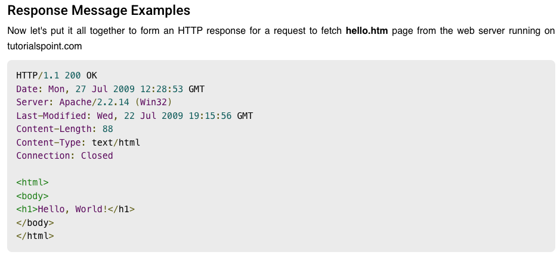

*// GET is the default method of fetch, so for GET we just provide URL*

*// Fetch returns a promise, so we use then and catch to get the results*

*// And normally we want to convert our responce to JSON*

fetch(*"*https://search.outdoorsy.com/rentals*"*)

.then(res *=>* res.json())

.then(data *=>* {

console.log(*'*success*'*, data)

})

.catch(err *=>* {

console.log(err)

})

APIs let your product or service communicate with other products and services without having to know how they’re implemented. This can simplify app development, saving time and money. When you’re designing new tools and products—or [managing](https://www.redhat.com/en/topics/management) existing ones—APIs give you flexibility; simplify [design](https://www.redhat.com/en/topics/api/what-is-api-design), administration, and use; and provide opportunities for innovation.

**REST**

REpresentational State Transfer (REST) is a software architectural style that developers apply to web APIs. REST APIs provide simple, uniform interfaces because they can be used to make data, content, algorithms, media, and other digital resources available through web URLs. Essentially, REST APIs are the most common APIs used across the web today.

1. Client-Server Separation

Under REST architecture, the client and server can only interact in one way: The client sends a request to the server, then the server sends a response back to the client. Servers cannot make requests and clients cannot respond — all interactions are initiated by the client.

By simplifying communication between clients and servers, RESTful APIs keep the two conveniently independent. This way, client software can grow their builds without worrying about affecting any other servers, and server contents can be modified without inadvertently affecting clients.

2. Uniform Interface

This guideline states that all requests and all responses must follow a common protocol, or a way of formatting their messages. Applications and servers are written in all sorts of different languages that don’t do a great job of working together without an intermediary. A uniform interface is a common language for any client to communicate with any REST API.

Without standardized communication, translating requests and responses between software would be a total mess. Minor discrepancies would cause information to be jumbled and lost, and applications would have to update their request processes whenever APIs updated theirs. A uniform interface eliminates this possibility.

For most REST APIs, this common language is HTTP, or Hyper-Text Transfer Protocol. HTTP wasn’t created specifically for REST. Rather, REST adopted this communication protocol as the standard for applications that use it.

To use HTTP with a REST API, the client sends a request in a specific format that might look familiar to you. For example, a request to the YouTube API for video data looks like this: GET <https://www.googleapis.com/youtube/v3/channels?part=contentDetails>

After receiving and validating the request, the host returns information about the target resource. Usually, the information is back sent in a format called JSON, which stands for JavaScript Object Notation. JSON lays out all the contents of a resource in a lightweight format that humans can easily read.

3. Stateless

All calls with a REST API must be stateless. This means that every interaction is independent, and each request and response provides all the information required to complete the interaction. Every request by the client is interpreted by the server as a brand new task — the server remembers nothing about past requests.

Stateless transfers greatly reduce the amount of server memory needed and improve the odds of a successful response, since the server is not required to take additional action to retrieve old data. This ensures that these interactions are scalable: As software grows and makes more requests, developers don’t need to worry about significantly more memory being used, or overloading the server with requests.

4. Layered System

So far I’ve described API requests as a simple interaction between a client and server, but this is a bit of a simplification. In reality, there are typically more servers between these two entities. These servers, or layers, are there to add security, handle and distribute traffic, or assist with a number of other important functions.

This principle requires that messages between the client and target server should always be formatted and processed the same way, regardless of layers that sit between them. Additional layers should not affect client-server interactions.

When developers follow this guideline, server systems can be rearranged, updated, or otherwise modified with no effect on the core request-response.

5. Cacheable

Caching occurs when media is stored on a client’s device when visiting a website. When a client returns to that site, the cached data is loaded quickly from local storage instead of being fetched again from the server. Caching saves server resources and bandwidth while decreasing page load time, which is why most large websites do it.

REST APIs are created with data caching in mind. When a server sends its response to a client, the response should indicate whether the resource provided can be cached, and for how long.

6. Code on Demand (Optional)

The final REST principle is optional. If desired, an API can send computer code to clients in its response. This empowers the client to run the code in its own backend.

As long as an API adheres to this set of rules, it is considered RESTful. However, these rules leave plenty of room for developers to customize the functionality of their API. This flexibility distinguishes REST APIs from another common web API method, the Simple Object Access Protocol (SOAP).

REST is considered a simpler, more efficient alternative to SOAP because it requires writing less code to complete tasks and follows a less rigid structure and logic than SOAP. Additionally, REST sets guardrails for API design, but leaves many choices up to the developer building the API.

**CURRYING**

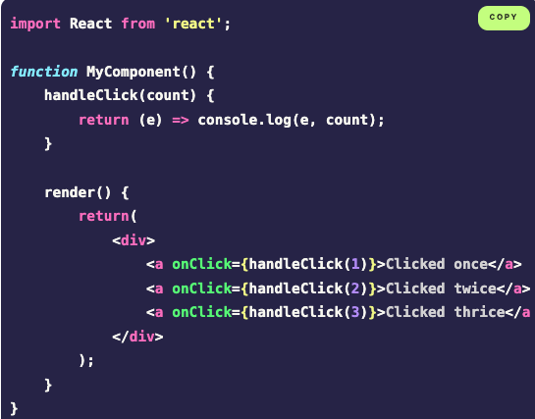

**SOLID**

**Single responsibility principle (SRP)**

The original definition states that “every class should have only one responsibility”, a.k.a. do exactly one thing. We can simply extrapolate the definition to “every function/module/component should do exactly one thing”. To ensure our components do one thing internally, we can:

* + break large components that do too much into smaller components
  + extract code unrelated to the main component functionality into separate utility functions
  + encapsulate connected functionality into custom hooks

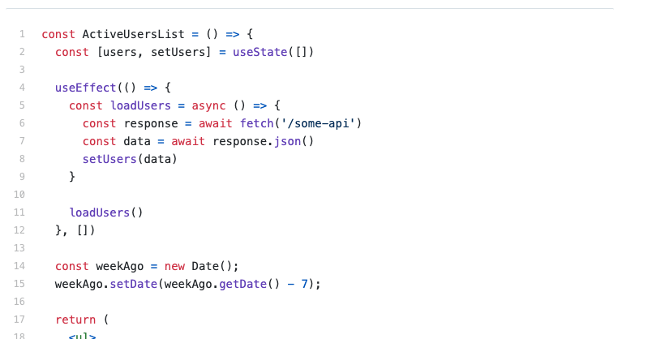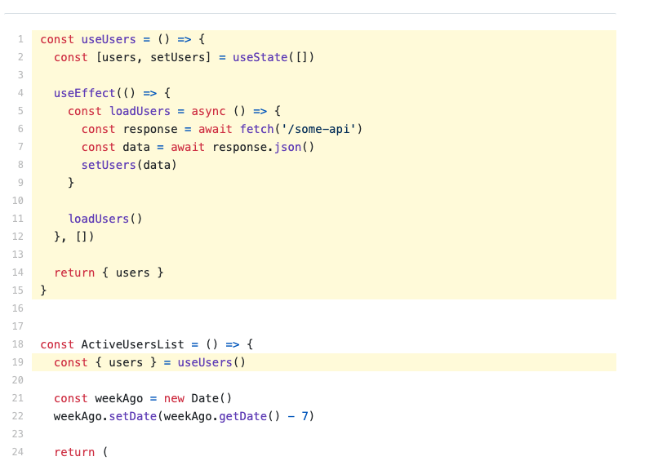

**Open-closed principle (OCP)**

OCP states that “software entities should be open for extension, but closed for modification”. In React terms, this can be boiled down to using composition rather than inheritance to create large-scale components. Luckily for us, React encourages this off the bat. This means you're probably already following this principle in your frontends without knowing it.

"At Facebook, we use React in thousands of components, and we haven't found any use cases where we would recommend creating component inheritance hierarchies. Props and composition give you all the flexibility you need to customize a component's look and behaviour in an explicit and safe way." - React Documentation, 2020

This pretty much means that we should always build big components from smaller ones, using props and special properties like props.children to build complexity when required.

The open-closed principle advocates for structuring our components in a way that allows them to be extended without changing their original source code.

To see it in action, let’s consider the following scenario - we’re working on an application that uses a shared Header component on different pages, and depending on the page we’re at, Header should render a slightly different UI:

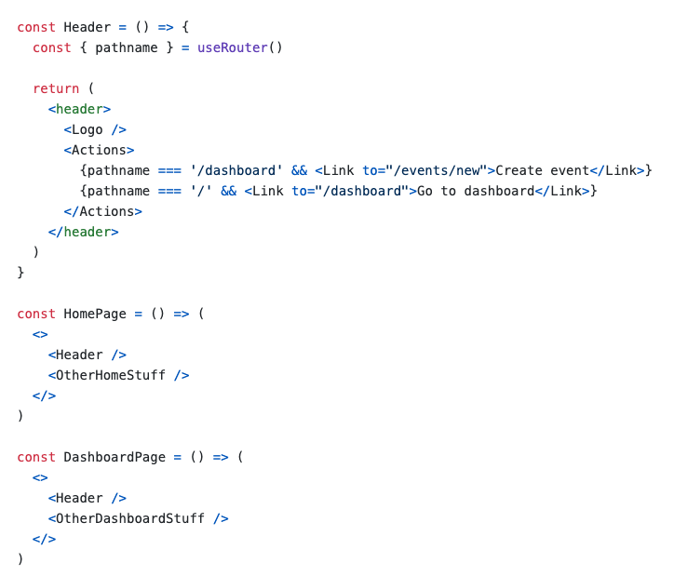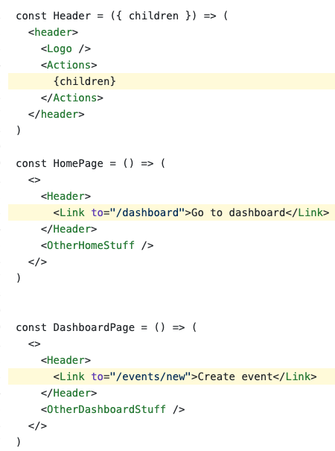

Here we render links to different page components depending on the current page we’re at. It’s easy to realize that this implementation is bad if we think about what will happen when we start adding more pages.

very time a new page is created, we’ll need to go back to our Header component and adjust its implementation to make sure it knows which action link to render. Such an approach makes our Header component fragile and tightly coupled to the context in which it’s used, and it goes against the open-closed principle.

To fix this problem, we can use component composition. Our Header component doesn’t need to concern itself with what it will render inside, and instead, it can delegate this responsibility to the components that will use it using children prop:

**We should strive to write code that doesn’t have to be changed every time the requirements change.** You should be able to extend the behavior of a system without having to modify that system.

An electric adapter is a good example of this principle. An adapter in the wall is always closed for modification, in other words we cannot change it once it is fitted or extended if we want more. But an adapter always provides a method of extension, so we can plug in an extension board of an adapter for more adaptation. Why should code be closed to modification? – less likely to introduce bugs in code we don’t touch or redeploy. –less likely to break dependent code when we don’t have to deploy updates. –fewer conditionals in code that is open to extension results in simpler code.

You should be able to extend the behavior of a system without having to modify that system.

**Liskov substitution principle (LSP)**

Overly simplified, LSP can be defined as a type of relationship between objects where “subtype objects should be substitutable for supertype objects”. This principle heavily relies on class inheritance to define supertype and subtype relationships, but it’s not very applicable in React since we hardly ever deal with classes, let alone class inheritance.

The LSP states that any subclass should be substitutable for its base class. [9] This means that if B extends A, then we should be able to use B everywhere we use A without altering any functionality.

To illustrate this principle, let's say we have some base class called Vehicle which has an engineNoise() method attached to it which makes the noise of the vehicle engine. We can extend a class called Car from this, which is fine as a car has an engine noise. However, if create Bicycle by extending Vehicle, we must shadow this engineNoise() method as bicylcles have no engine noise, therefore we will throw an error if someone tries to call engineNoise() on Bicycle.

If we attempt to call makeVehicleEngineNoise() with the subclass of Vehicle, Bicycle, we get an error (an error we needed to add, as we don't want people to be able to call engineNoise on a bicycle). This means that we cannot replace every instance of Vehicle with Bicycle and keep the same functionality. If we wanted to do this, we would instead need to alter our Vehicle class to only contain properties/methods which all possible subclasses would have.

Since not all of the methods implemented in the parent are relevant for each of the child classes, they have to override the implementation of them which means they violate the LSP. In a vehicle, you should be able to replace a part with a different part, and the car would keep working. Let's say your old radio doesn't have a digital tuner, but you want to listen to HD radio so you buy a new radio that has an HD receiver. You should be able to take the old radio out and plug in the new radio, as long as it has the same interface. On the surface, that means the electrical plug that connects the radio to the car needs to be the same shape on the new radio as it is on the old radio. If the car's plug is rectangular and has 15 pins, then the new radio's jack needs to be rectangular and have 15 pins as well.

**Interface segregation principle (ISP)**

According to ISP, “clients should not depend upon interfaces that they don’t use.” For the sake of React applications, we’ll translate it into “components shouldn’t depend on props that they don’t use”. We’re stretching the definition of the ISP here, but it’s not a big stretch - both props and interfaces can be defined as contracts between the object (component) and the outside world (the context in which it’s used), so we can draw parallels between the two. In the end, it’s not about being strict and unyielding with the definitions, but about applying generic principles in order to solve a problem. An implementation detail is some specific way a task is accomplished. For instance, "getting todos from the API" is a task we can accomplish by using the axios library (an implementation detail). Another task might be "storing users in a database"; our choice of database is an implementation detail for this task.

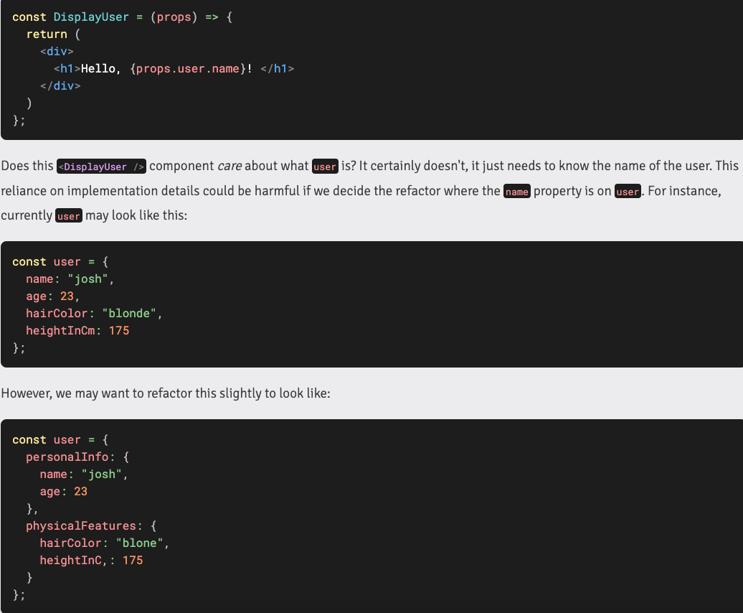

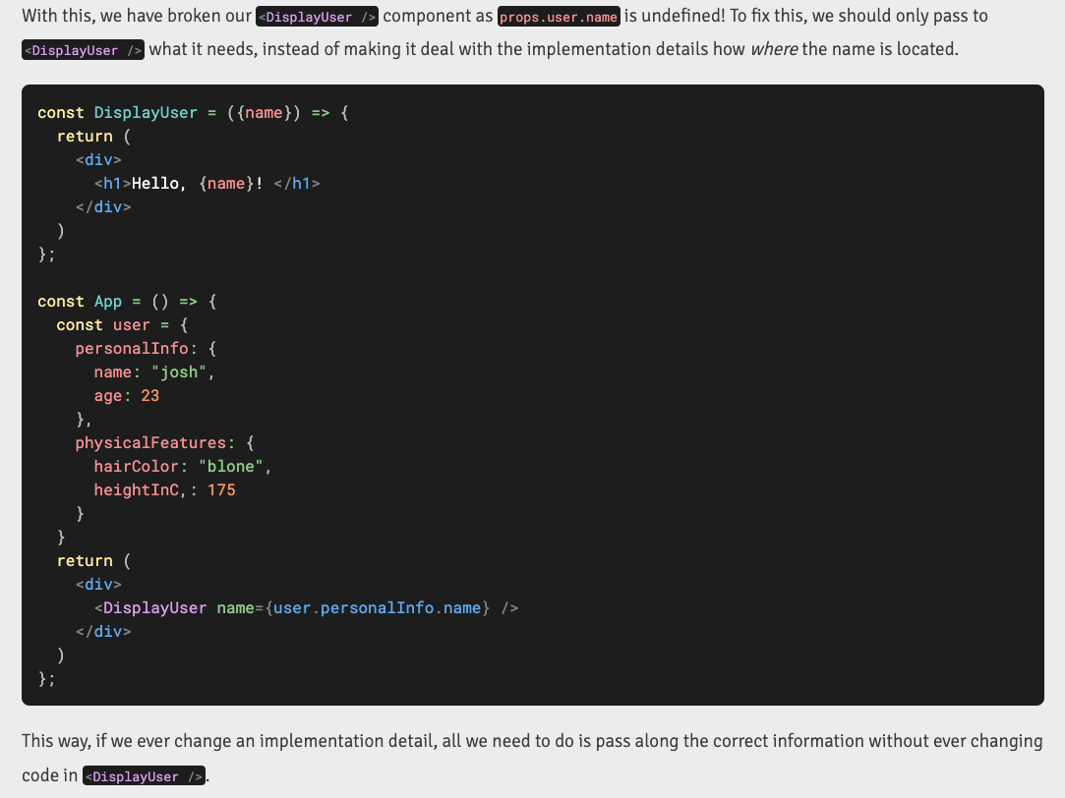

Destructure out the needed props for a component if possible. This way, the component does not rely on the details in its parent component.

**Dependency inversion principle (DIP)**

The dependency inversion principle states that “one should depend upon abstractions, not concretions”. In other words, one component shouldn’t directly depend on another component, but rather they both should depend on some common abstraction. Here, “component” refers to any part of our application, be that a React component, a utility function, a module, or a 3rd party library.

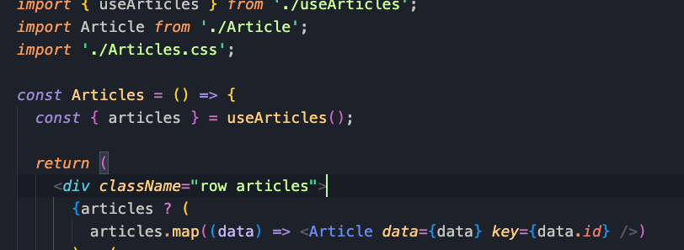

Тук например комп. Атикълс не се интересува откъде и как идват те, това е работа на useArticles() custom hook: Също така всички импортнати модули са DI

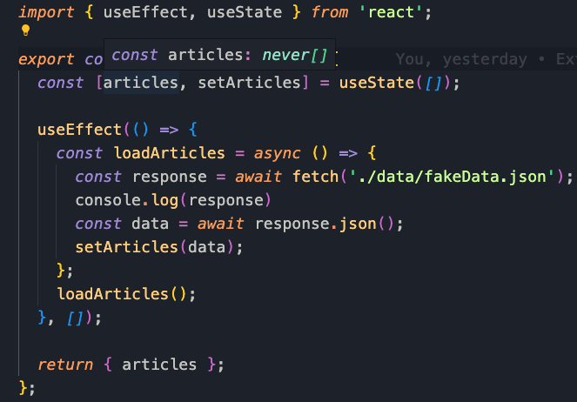

**Abstraction:** DI ни позволява да постигнем Абстракция. При нея, детаилите от даден обект не ни вълнуват, а ни касае само това, което ни трябва и което е релевантно към проблема, който решаваме. Abstraction is something we do every day. We see the qualities of an object that have meaning to us. When you use your smartphone, you use it through its interface, when you drive your car, you interact with the interface, you are not coupled with a specific car.

It means ignoring irrelevant features, properties or functions and emphasizing the relevant ones… With an eye to future reuse in similar projects. Abstraction helps manage complexity.In C# abstraction is achieved in several ways: interfaces, abstract classes(they might have some implementation) and inheritance.

**What is Data Encapsulation?**

An object's ability to hide data and behavior that are not necessary to its user. Also called “information hiding”. An object has to provide its users only with the essential information for manipulation, without the internal detals.

* Protection of data from accidental corruption
* Specification of the accessibility of each of the members of a class to the code outside the class
* Flexibility and extensibility of the code and reduction in complexity
* Lower coupling between objects and hence improvement in code maintainability

We can also achieve it through DI in the above example – it provides with lower coupling, it is protected as we cannot change it from outside. Custom hooks are example of encapsulation

**What is Polymorphism in C# ?**

Концепцията, че обекти от различни типове могат да се достъпват чрез един и същ Интерфейс. It allows treating objects of a derived class as objects of its base class. For example big cats(base class) catch their pray(a method) in different ways.

Static Polymorphism(early binding) – **Method Overloading** represents a static form of polymorphism. It is carried out **at compile time**

**Dynamic polymorphism -** This form of polymorphism doesn’t allow the compiler to determine the executed method – **Method Overriding** dynamic polymorphism, the type of the object from which the overridden method will be called is identified at **run time**. It is implemented through inheritance and the use of the keyword "virtual". Derived classes inherit the base class members, except constructors, based on their accessibility levels.

The ability to work with a group of related objects in a uniform way. A class can be used through its parent interface. A child class may override some of the behavior of the parent class.

Functional programming

Functional programming became a thing because of the beautiful simplicity of pure functions that, given the same inputs, a pure function will return the same output. The reason people started embracing functional languages was that, for the most part, they did away with state in favor of just passing functions everywhere.

## **Can you name two programming paradigms important for JavaScript app developers?**

JavaScript is a multi-paradigm language, supporting **imperative/ procedural** programming along with **OOP** (Object-Oriented Programming) and **functional programming**. JavaScript supports OOP with **prototypal inheritance**.

Prototypal inheritance (also: prototypes, OLOO).

* Functional programming (also: closures, first class functions, lambdas).
* What is functional programming?

Functional programming produces programs by composing mathematical functions and avoids shared state & mutable data. Lisp (specified in 1958) was among the first languages to support functional programming, and was heavily inspired by lambda calculus. Lisp and many Lisp family languages are still in common use today.

* Pure functions / function purity.
* Avoid side-effects.
* Simple function composition.
* Examples of functional languages: Lisp, ML, Haskell, Erlang, Clojure, Elm, F Sharp, OCaml, etc…
* Mention of features that support FP: first-class functions, higher order functions, functions as arguments/values.

## What is the difference between classical inheritance and prototypal inheritance?

**Class Inheritance:**instances inherit from classes (like a blueprint — a description of the class), and create sub-class relationships: hierarchical class taxonomies. Instances are typically instantiated via constructor functions with the `new` keyword. Class inheritance may or may not use the `class` keyword from ES6.

**Prototypal Inheritance:** instances inherit directly from other objects. Instances are typically instantiated via factory functions or `Object.create()`. Instances may be composed from many different objects, allowing for easy selective inheritance.

In JavaScript, prototypal inheritance is simpler &  
more flexible than class inheritance.

* Classes: create tight coupling or hierarchies/taxonomies.
* Prototypes: mentions of concatenative inheritance, prototype delegation, functional inheritance, object composition.

## What are the pros and cons of functional programming vs object-oriented programming?

**OOP Pros:**It’s easy to understand the basic concept of objects and easy to interpret the meaning of method calls. OOP tends to use an imperative style rather than a declarative style, which reads like a straight-forward set of instructions for the computer to follow.

**OOP Cons:** OOP Typically depends on shared state. Objects and behaviors are typically tacked together on the same entity, which may be accessed at random by any number of functions with non-deterministic order, which may lead to undesirable behavior such as race conditions.

**FP Pros:** Using the functional paradigm, programmers avoid any shared state or side-effects, which eliminates bugs caused by multiple functions competing for the same resources. With features such as the availability of point-free style (aka tacit programming), functions tend to be radically simplified and easily recomposed for more generally reusable code compared to OOP.

FP also tends to favor declarative and denotational styles, which do not spell out step-by-step instructions for operations, but instead concentrate on **what** to do, letting the underlying functions take care of the **how**. This leaves tremendous latitude for refactoring and performance optimization, even allowing you to replace entire algorithms with more efficient ones with very little code change. (e.g., memoize, or use lazy evaluation in place of eager evaluation.)

Computation that makes use of pure functions is also easy to scale across multiple processors, or across distributed computing clusters without fear of threading resource conflicts, race conditions, etc…

**FP Cons:** Over exploitation of FP features such as point-free style and large compositions can potentially reduce readability because the resulting code is often more abstractly specified, more terse, and less concrete.

More people are familiar with OO and imperative programming than functional programming, so even common idioms in functional programming can be confusing to new team members.

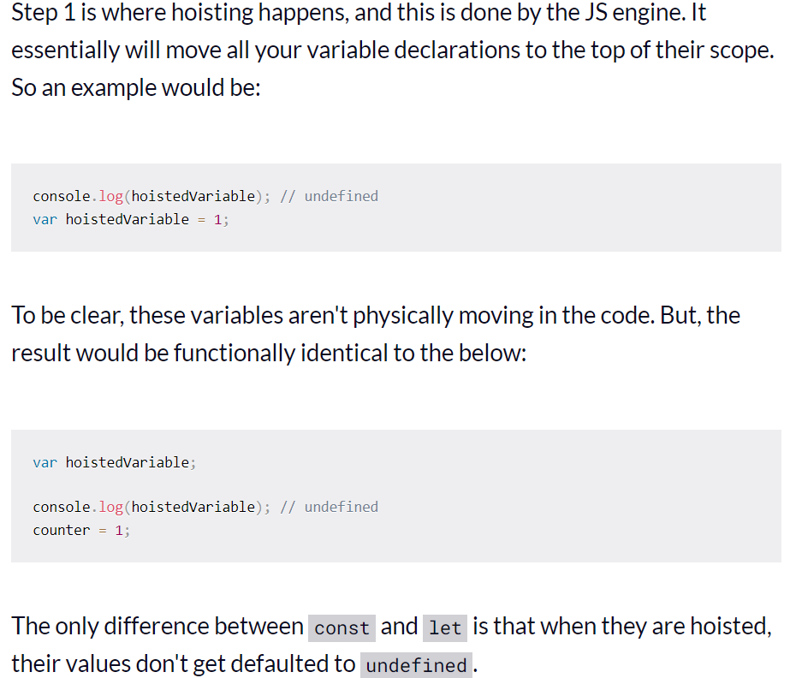 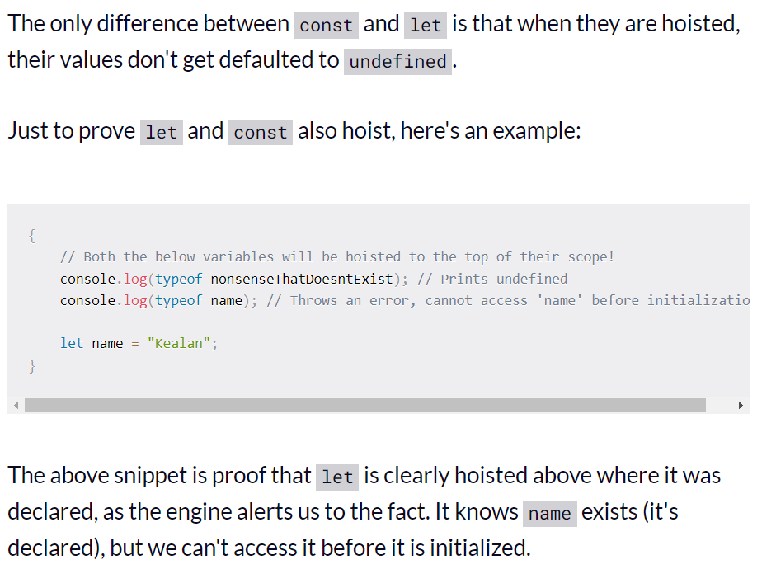

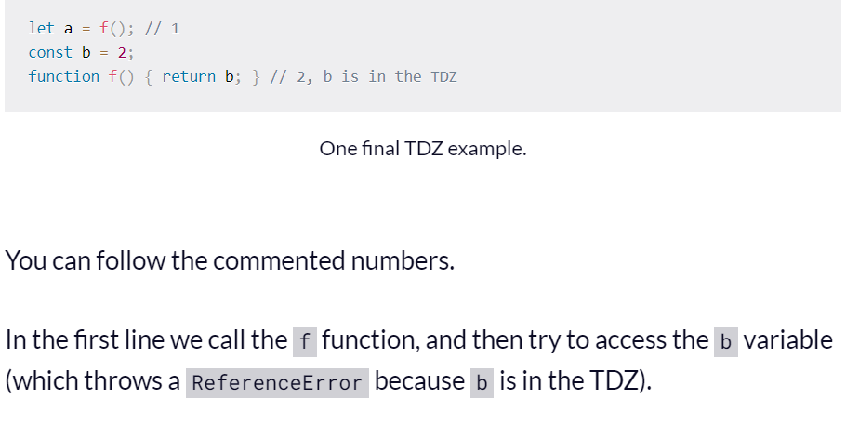

It helps us catch errors.

To try and access a variable before it is declared is the wrong way round, and shouldn't be possible.

It also gives more expected and rational semantics for const (because const is hoisted, what happens if a programmer tries to use it before it is declared at runtime? What variable should it hold at the point when it gets hoisted?)

always make sure you define your lets and consts at the top of your scope.

**Hoisting** is the process of moving function declarations to the top of the file. And this is done automatically by the JS engine that is executing the code

**CLASSES**

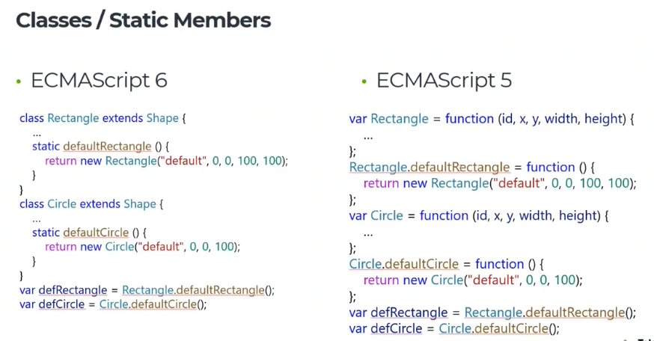

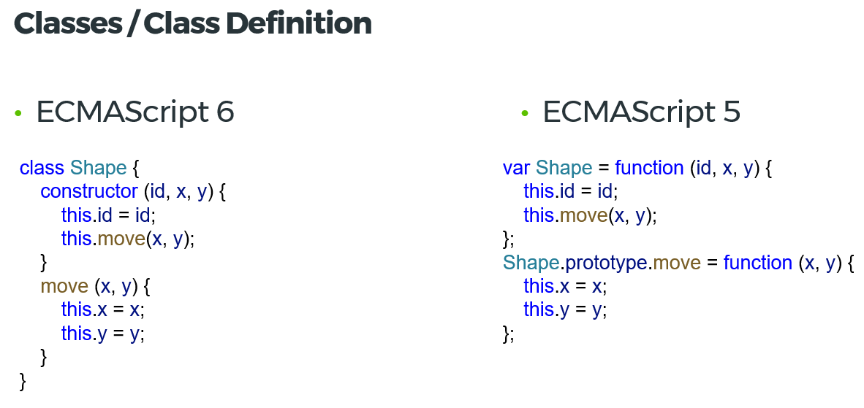

**This** keyword. Когато извикаме draw() метода като функция, by default ‘this’ will point to the global object – window in the browser and global in node.js

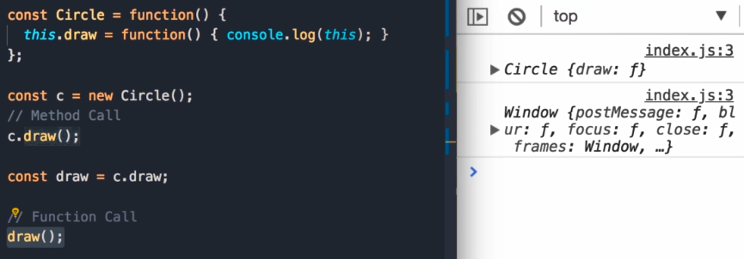

By default the body of our classes are executed in strict mode

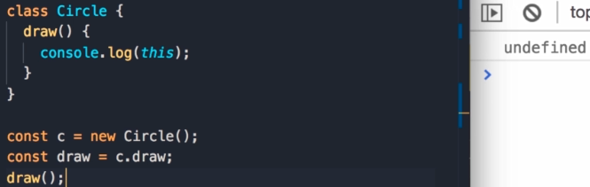

Inheritance in ES6. With the extend keyword we don’t have to reset the constructor

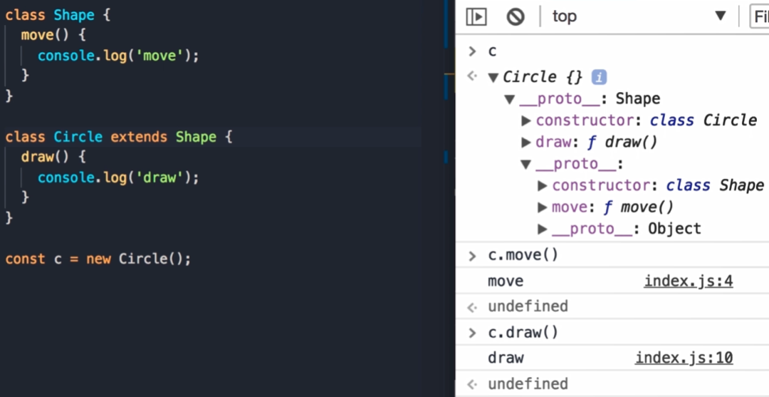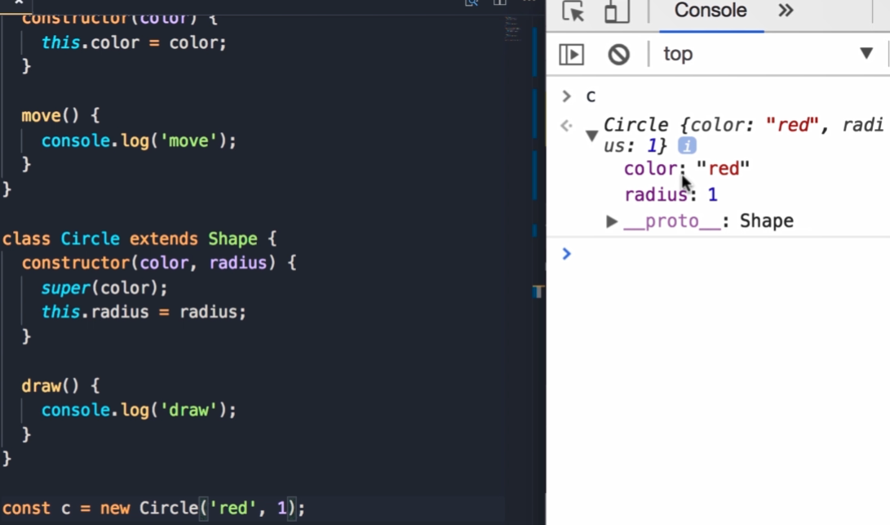

Ако искаме да достъпим move() ot base object we use super.move().

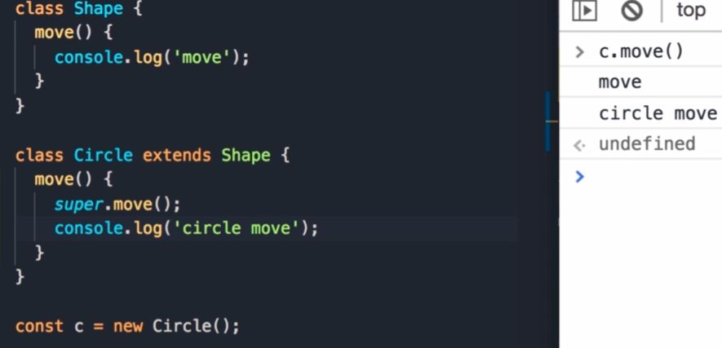

Prototype vs Instance Members

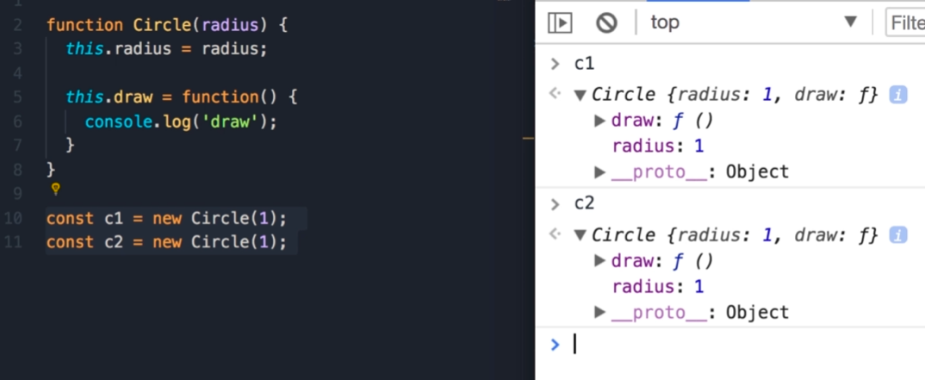

В тази имплементация, ако имаме 1000 Circle обекта в паметта, ще имаме 1000 копия на метода draw(). Ако и имаме повече от един метод, ще изразходваме много излишна памет за запазване на тези методи.

Решението е да извадим метода draw() от Circle обекта и да го сложим в неговия прототип. Ще имаме единствена инстанция на този прототип (която ще наричаме circleBase). Така ще имаме само една инстанция на draw(). Circle.prototype === c1.__proto__ -> тези пропъртита сочат към един и същи обект в паметта(circleBase)

Това имаме в паметта:

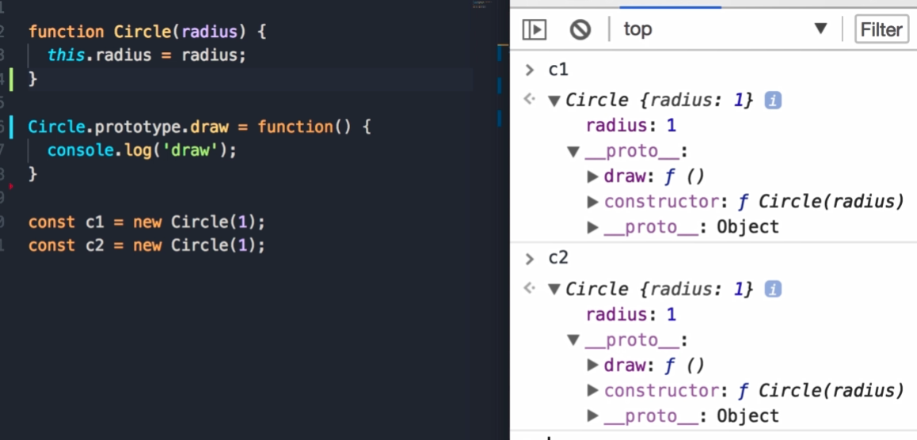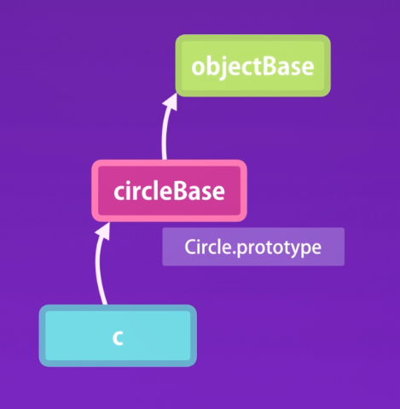

Съответно имаме два вида пропърти и методи – Instance members & Prototype members. И в двата вида members може да reference members от другия вид:

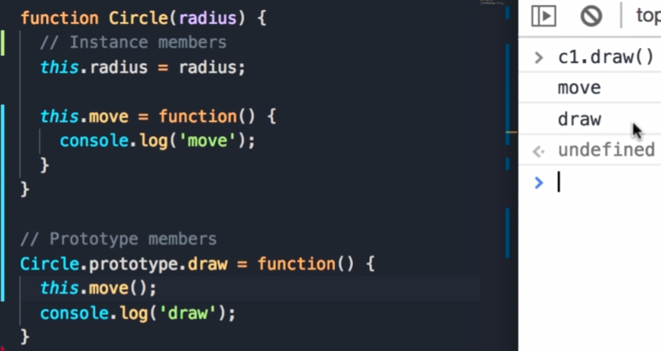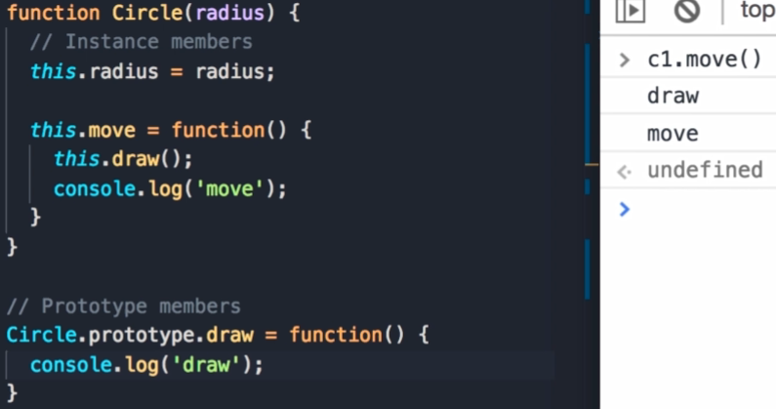

Object.keys връща само Instance members. For in връща всички members instance(own) + prototype

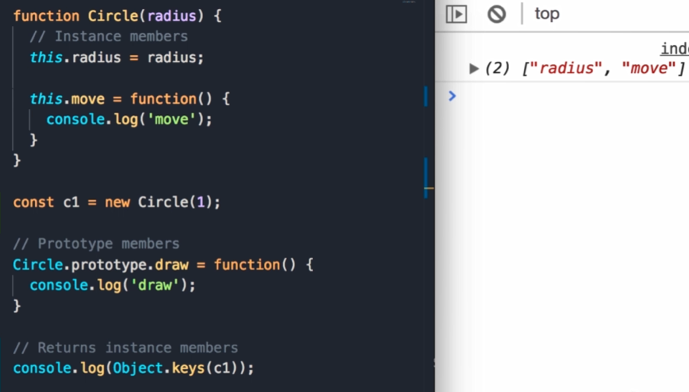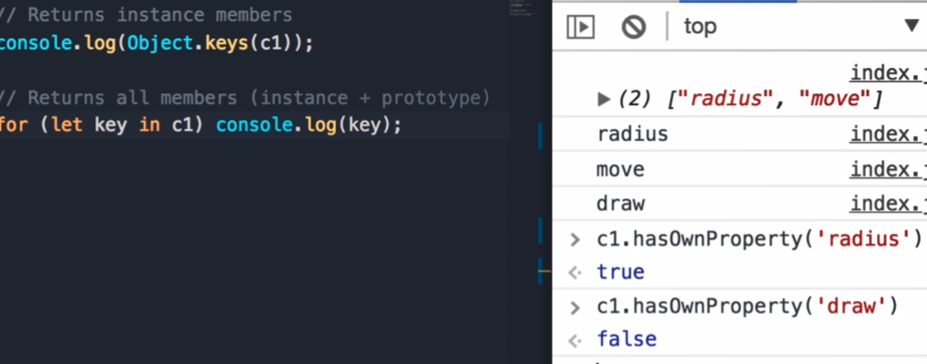

Avoid extending the Built-in Objects – i.e. Array.prototype.shuffle – function() {}; - Don’t modify objects you don’t own!

Prototypical Inheritance

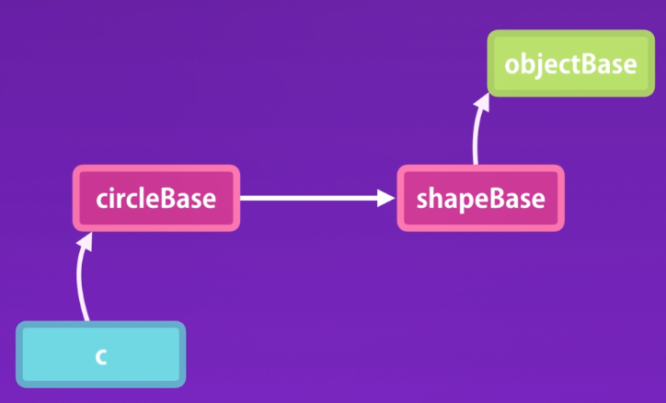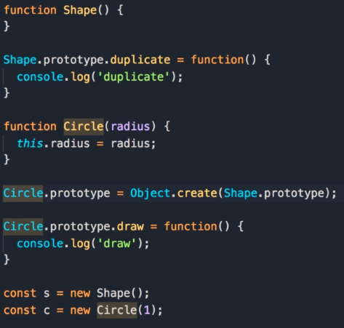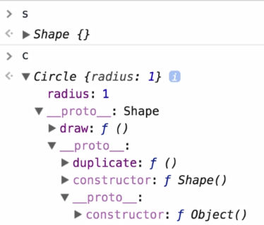

Ако искаме Circle да наследява Shape, използваме Object.create method.

Всеки обект в JS има constructor property, който връща функцията използвана за създаването му.

Ако закоментираме следния ред и инспектнем Circle, виждаме, че constructor references our Circle function. Можем да използваме new Circle.prototype.constructor(1) за създаване на обект, еквивалентно е с new Circle(1).

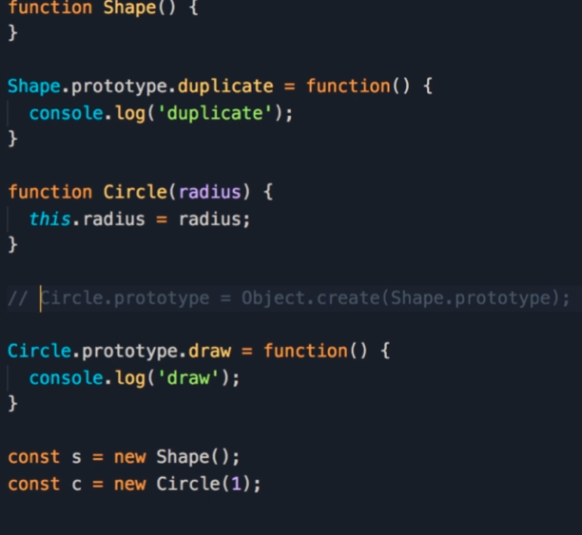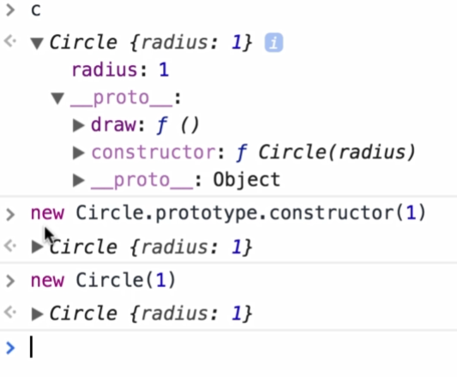

Ако обаче разкоментираме горния ред, конструкторът връща Shape function, not Circle function. Иначе казано, не можем да създаваме обекти от тип Circle базирани на неговия конструктор динамично. Виждаме, че прототипа на Circle дава Shape обект. Причината за това е, че ресетваме прототипа на Circle (Circle.prototype = Object.create(Shape.prototype). Преди него прототипа на Circle имаше следното пропърти: Circle.prototype.constructor = Circle; затова можеше да използваме new Circle.prototype.contructor(), което е същото като new Circle();

**Така, че винаги, когато рисетваме прототипа на обект, трябва също така да рисетваме и конструктора**

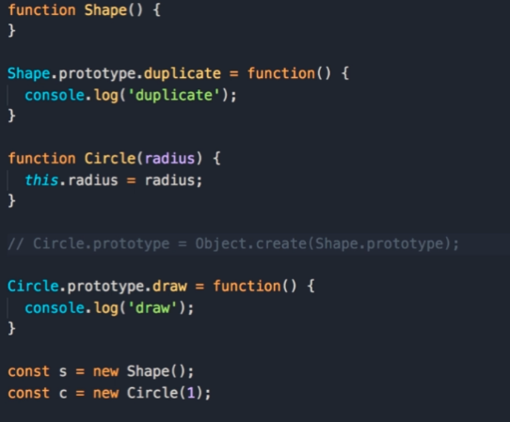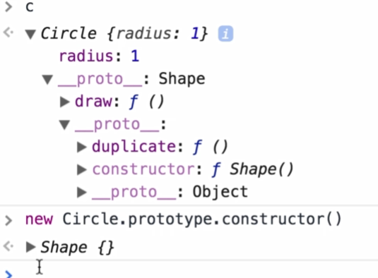 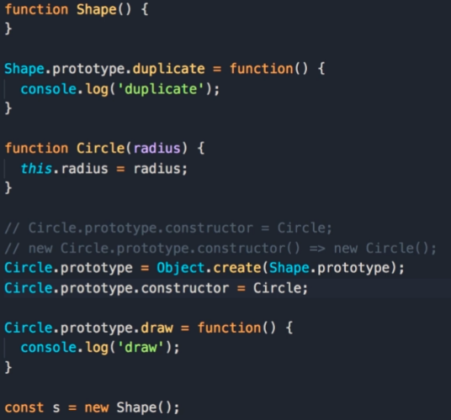 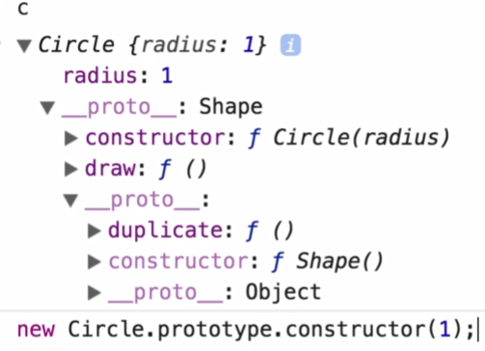

Когато използваме new operator се случват три неща: създава нов празен обект и след това задава this да сочи към този обект и накрая този нов обект бива върнат от конструктора. Ако не използваме оператора new, this by default ще сочи към глобалния обект – window in the browser and global in node.

За да извикаме конструктора на parent обекта(super constructor), използвамe Shape.call method. Ако искаме всеки Shape да има color:

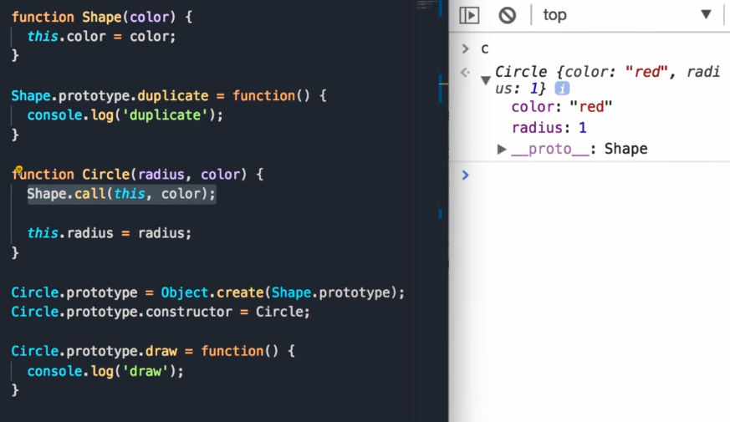

Когато имаме повече от 1 обект и правим prototype chain, е добре да extract into a function we can reuse:

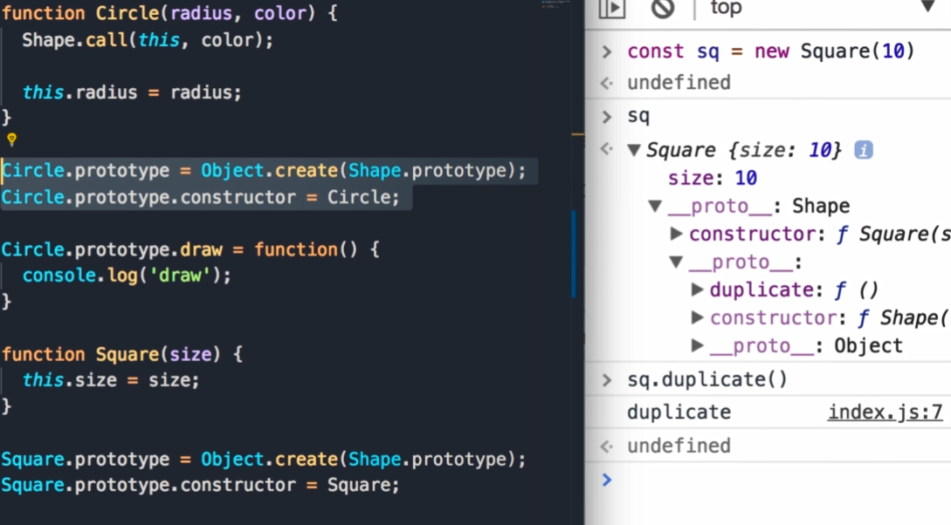 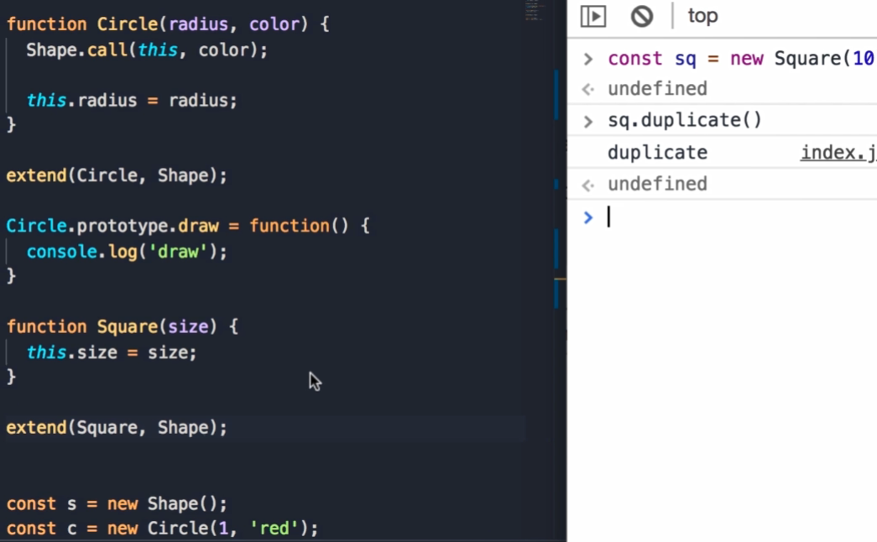

Method Overriding(реимплементиране на даден метод в наследяващ обект) – когато работим с наследяване понякога имплементацията на даден метод в parent обекта не ни върши работа в наследяващия обект. Това се прави като предефинираме този метод в наследяващия обект. Много е важно това да стане след като extend обекта. Прототипното наследяване работи – когато достъпваме порпърти или метод на даден обект JS engine тръгва по prototype chain и избира първата имплементация. В случая – ‘duplicate circle’

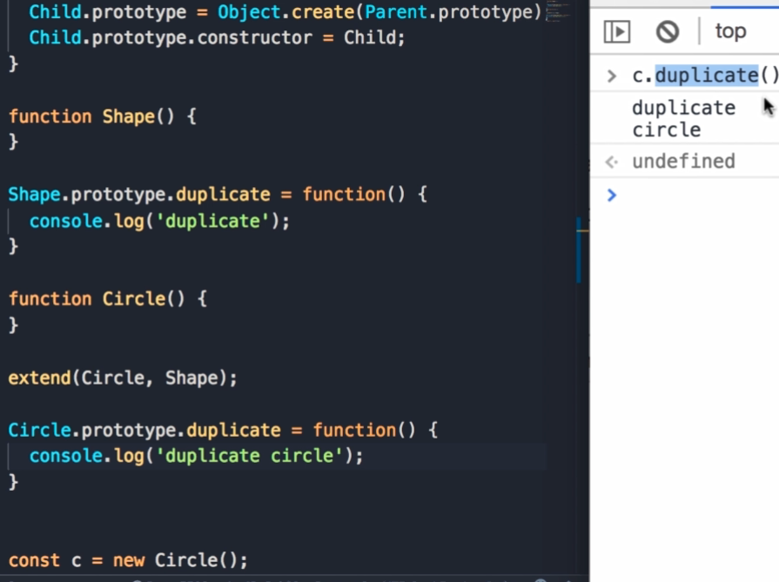

Ако искаме да извикаме имплементацията от parent обекта: ако не използваме ‚this’ в parent имплементацията можем просто да я извикаме като функция – Shape.prototype.duplicate(); Ако сме използвали ‚this’, тогава трябва да използваме call method, за да зададем контекста към ‚this’ - – Shape.prototype.duplicate.call(this)

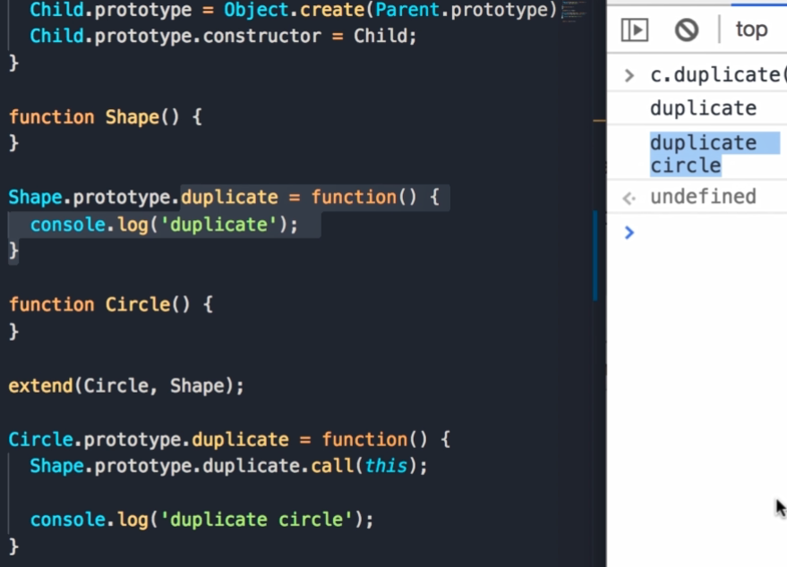

**Polymorphism**: Ако дефинираме нов обект Square наследяващ Shape, който има своя имплементация на duplicate метода. Имаме прост йерархия - на върха имаме Shape и два child objects – Circle & Square. Всеки един от двата обекта има различна имплементация на метода duplicate, съответно имаме много имплементации или много форми на този метод. Това е полиморфизъм. Когато енкапсулираме променливи и функции в обект и използваме наследяване, по този начин можем да изпълняваме много форми на даден метод, използвайки един ред код:

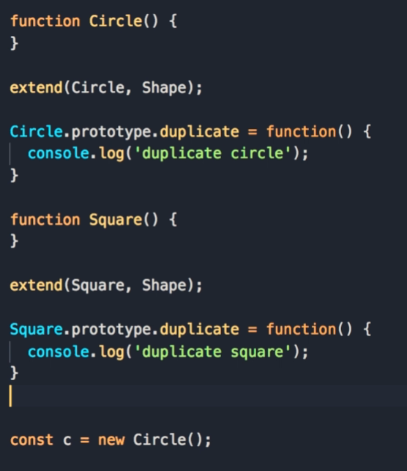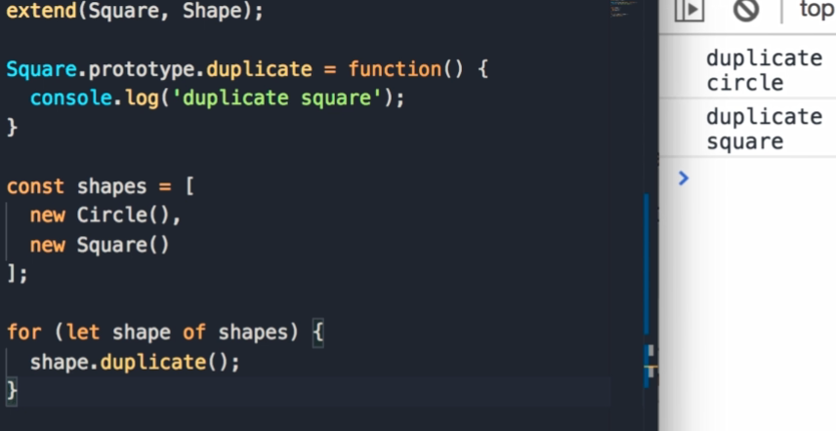

Добра идея е да не прекаляваме с наследяването, особено в малки проекти. KISS – keep it simple, stupid. Добре е да започваме с прости обекти и след това ако забележим, че няколко от тях споделят подобна функционалност, тогава може да ги капсулираме в обект и да използваме наследяване. Но наследяване не е единствения начин за преизползване на код. Друга такава техника е **Composition.** Ако имаме Animal object with two methods – eat() & walk и имаме два обекта, които го наследяват – Person & Dog. Ако след това трябва да създадем обект Goldfish, който наследява Animal, то тогава нашата йерархия е счупена, защото рибката не може да ходи, тя плува:

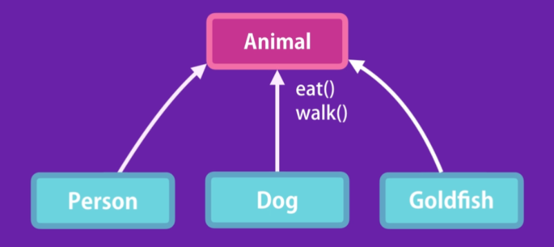

За да разрешим проблема, трябва да променим йерархията:

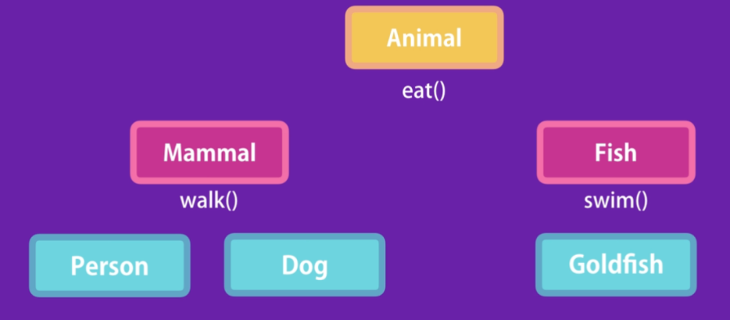

В резултата на това, че добавихме нов вид животно, трябваше да си променим йерархията и сега тя е по-сложна от преди. Ако пък имаме 10 вида животни, би станала още по-сложна. **Трябва да избягваме да създаваме йерархии от наследяване. Ако ще използваме наследяване, не трябва да е повече от едно ниво на наследяване.**

**Композицията е за предпочитане пред наследяването.** При нея, вместо да имаме сложна йерархия като горната, можем да композираме няколко обекта заедно, за да създадем нов обект и това ни дава голяма гъвкавост. В предния пример, вместо да използваме наследяване, можем да дефинираме различни характеристики(features) на нашите животни като независими обекти. We can have three objects – canWalk, canEat, canSwim. Всички те са plain js objects със съответните пропъртита и методи.  phoNow we want to have a Person object – we simply compose those three objects to create a person object. Tomorrow we want to introduce Goldfish – we can compose canEat, canSwim together to produce a Goldfish. So we don’t have a hierarchy and we can come up with any combination of these objects to create new objects. In js we can use Mixins to achieve composition

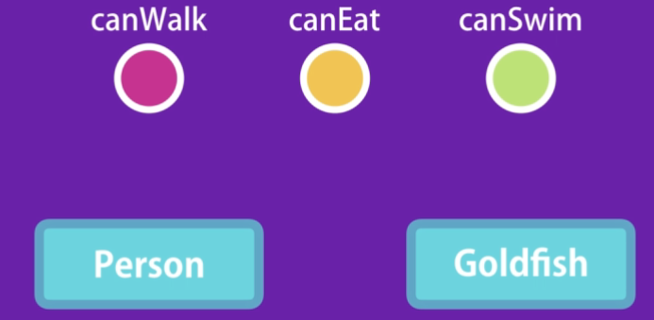

Дефинираме една функционалност като обект (canEat, canWalk). След това можем да композираме тези обекти заедно и да създадем Person, който да може яде и ходи(Object.assign({}, canEat, canWalk) – даваме празен обект като първи параметър и assign ще копира всички пропъртита и методи ot canEat, canWalk в празния обект. По този начин новият обект е комбинация от другите два:

Можем да го направим и ако използваме constructor function:

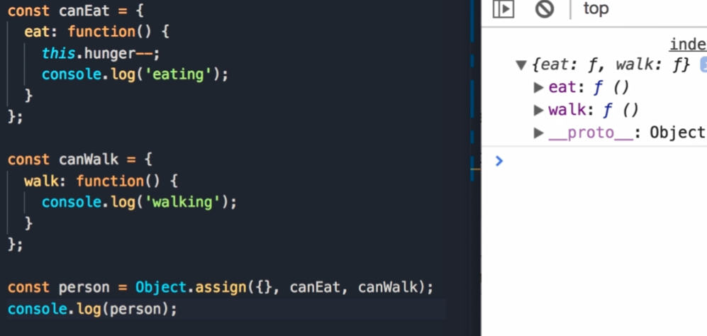 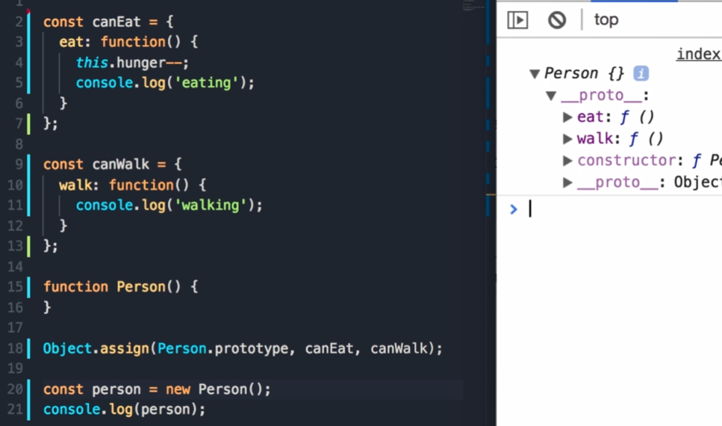

Ако искам да добавим два нови обекта – Goldfish & Duck. Both should have the capability to swim:

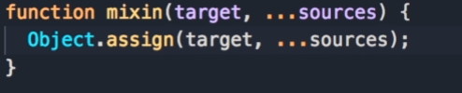 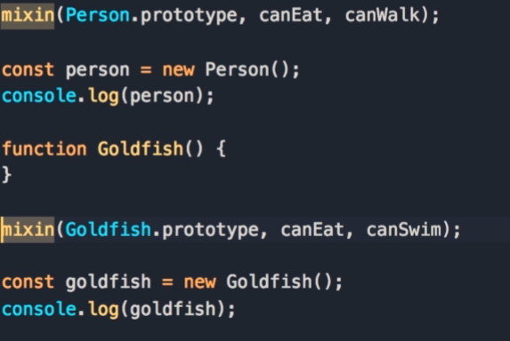

**ES6 Classes –** they are essentially a syntetic sugar over prototype inheritance, they are not real classes

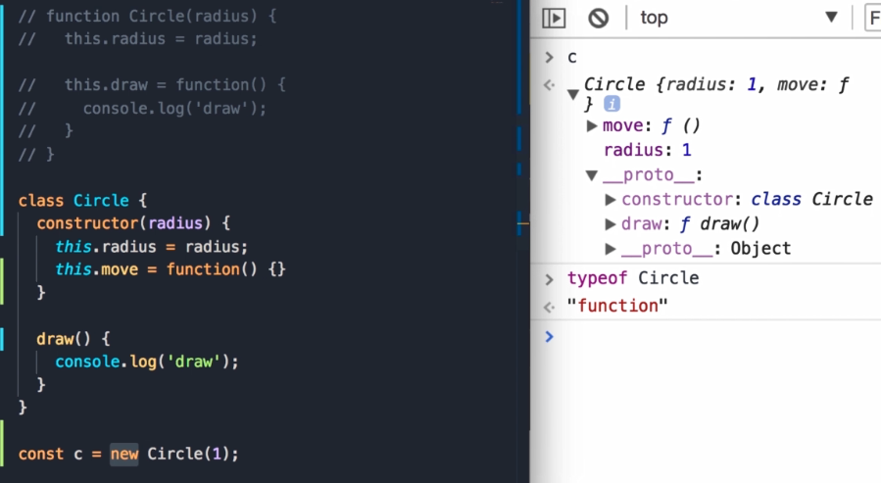

В JS има два начина на деклариране на функции: 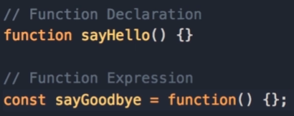 Function declaraions are hoisted, which means they are raised to the top of the code. Така че може да я извикаме преди нейната декларация. Func. Expr. Are not hoisted и ако я извикаме преди нейната декларация, получаваме грешка “is not defined”.

При класовете няма hoisting:

